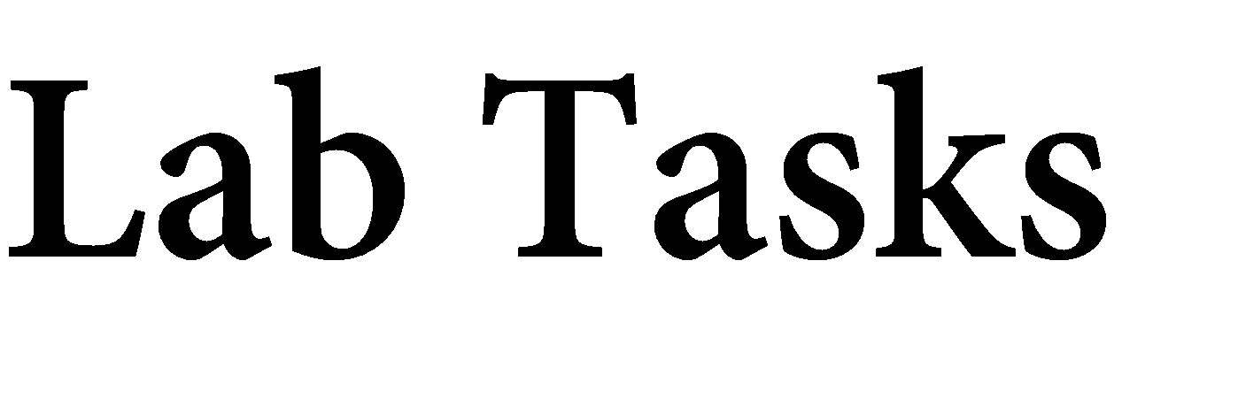

Name: Muhammad Faisal
Roll no: 2022F-BCS-152

Section: A
Instructor Name: Miss Fozia Khan
Course: Artificial Intelligence Lab (CS - 325L)
Program: (BS) - Computer Science

Lab #00

Tasks 01 : Install the anaconda Nav.
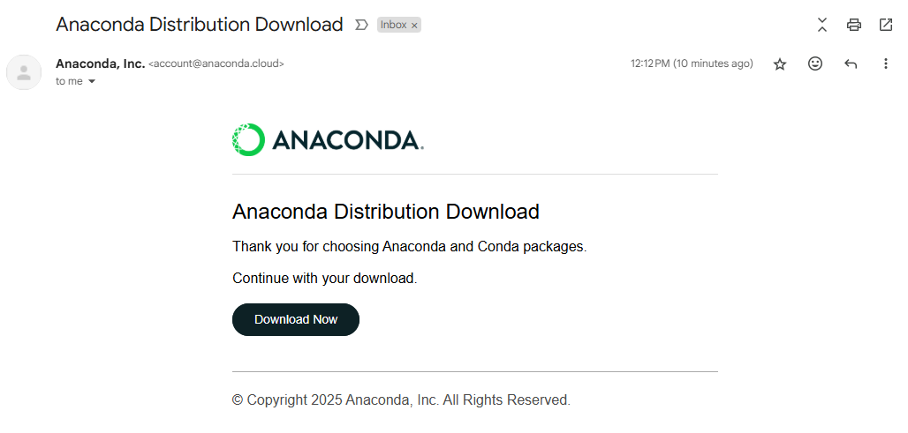



Task 02 : Answer the following.
- What is Environment?
In computing, an environment refers to a setup or space where software or applications run. It includes the configuration, tools, libraries, and system settings needed for development, testing, or deployment.
Examples:
- Development environment (for coding and testing)
- Production environment (for running the actual app used by users)
- Virtual environments (isolated setups for specific projects)
- Why do we make an Environment?
We make environments to:
- Keep things organized (separate development from production)
- Avoid conflicts between software packages or dependencies
- Test safely without affecting live applications
- Control versions of tools or libraries per project

- How do we make an Environment? Create one.
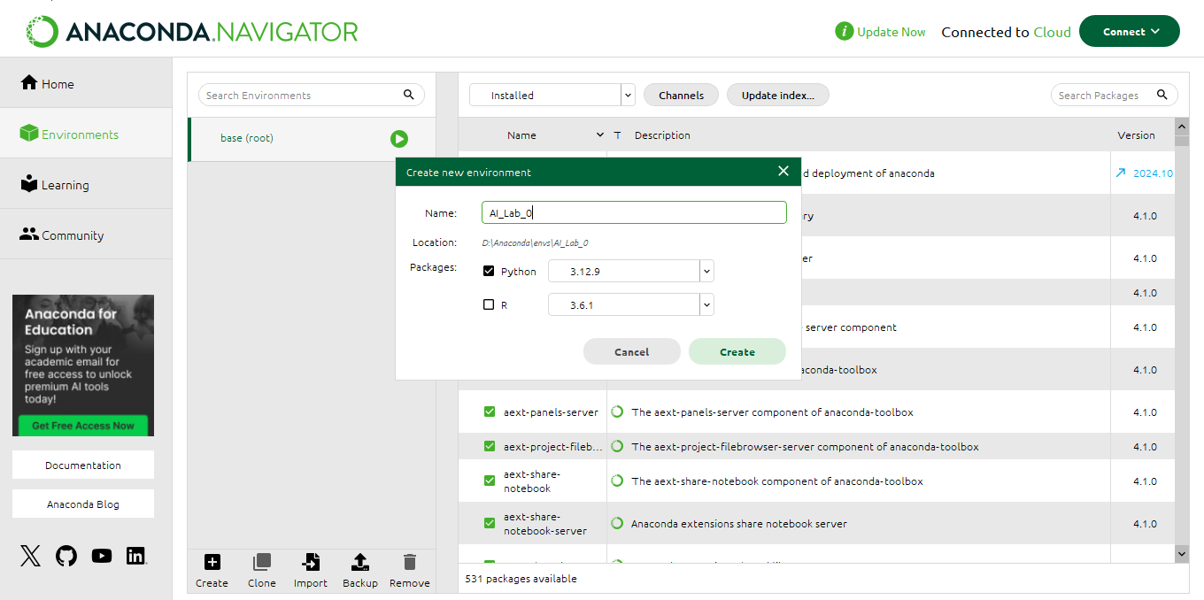

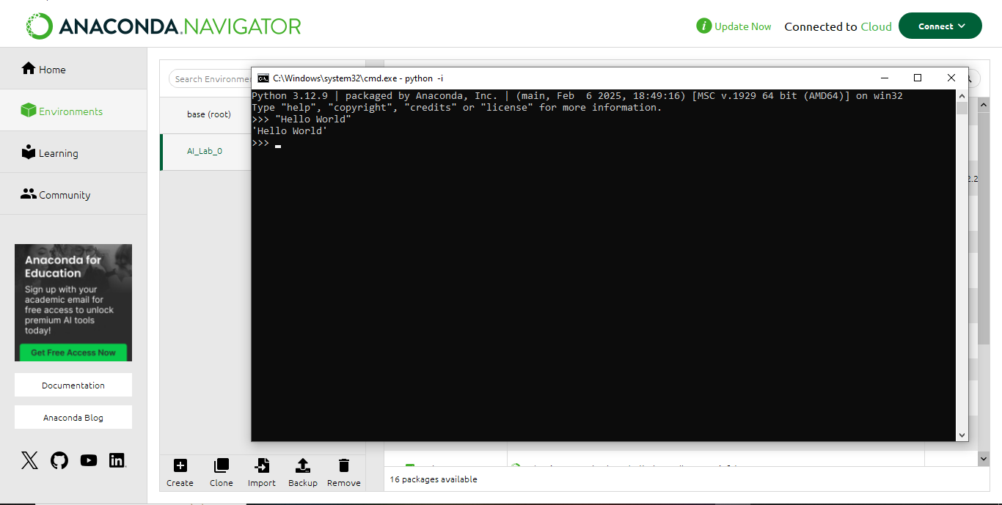

Task 03: Create an empty file on Jupyter notebook and rename it using your Roll no. [Show all the steps].
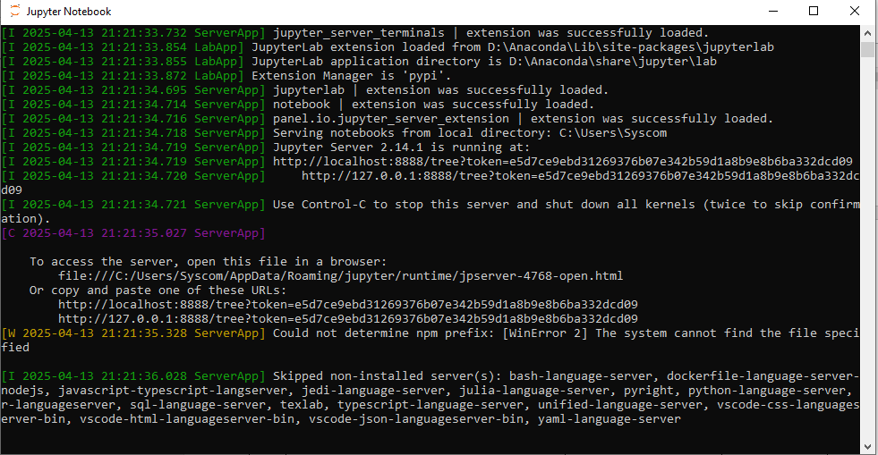

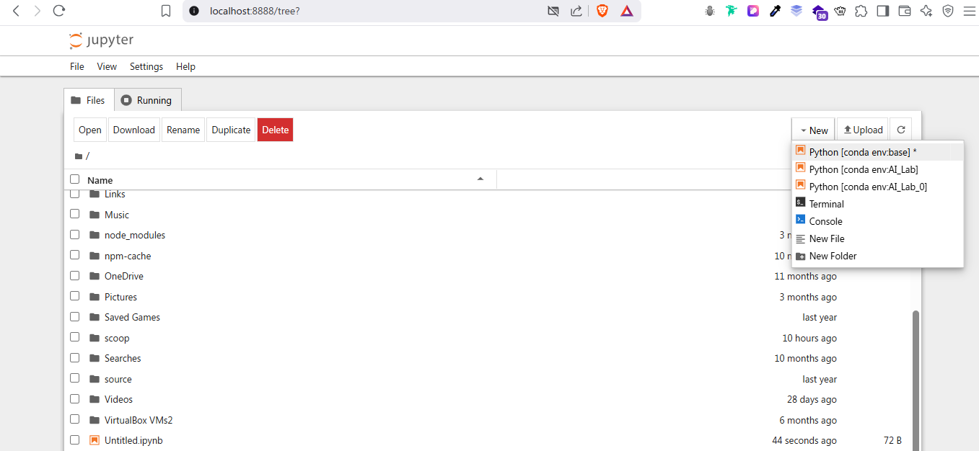

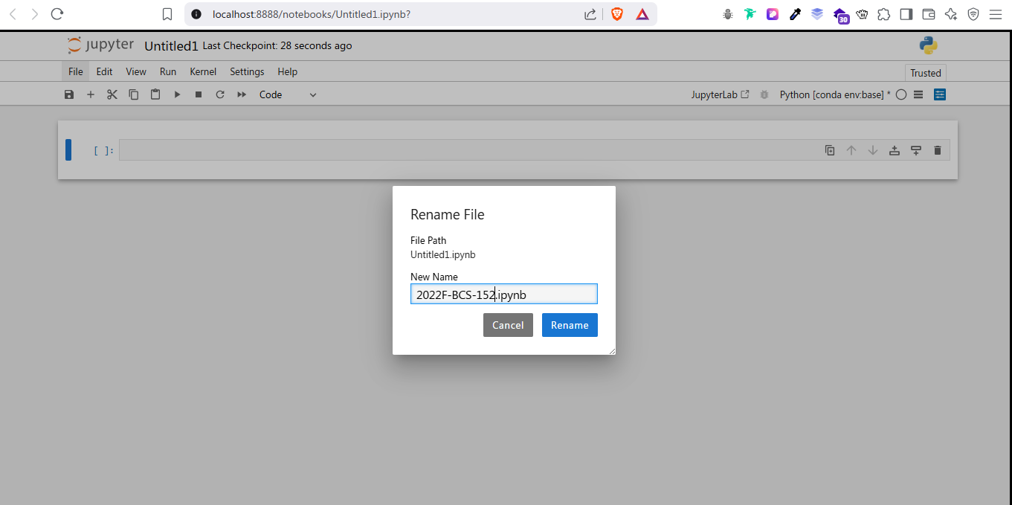

Task 04: Print your name along with your fathers on the notebook created earlier.
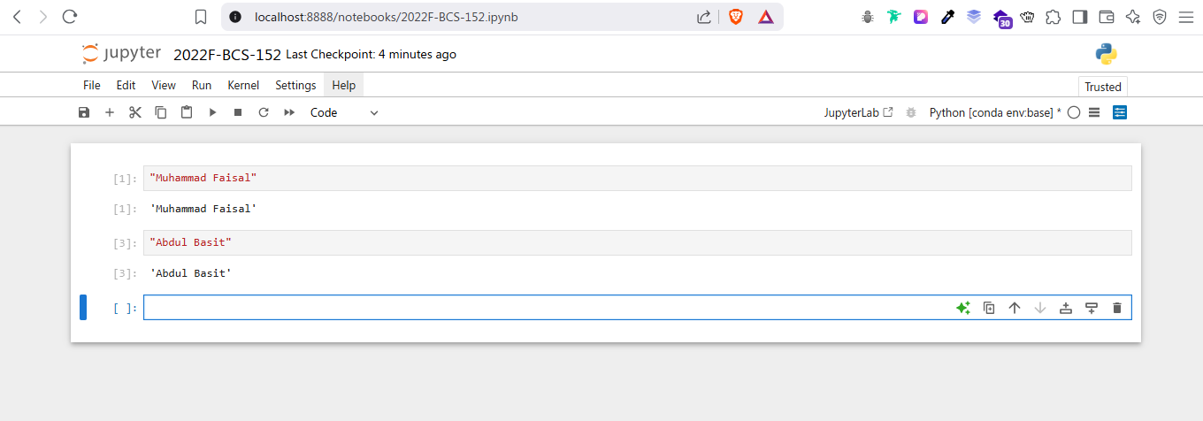

Lab #01
Activity- 1:
Write a script that take user input for a number then adds 3 to that number. Then multiplies the result by 2, subtract 4, then again adds 3, then print the result.
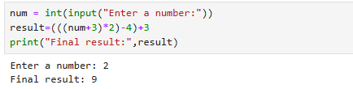

Activity- 2:
Write a script that takes input as radius then calculate area of circle. (Hint: A= πr²).
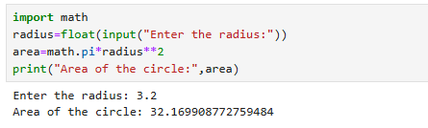

Activity- 3:
Write a Python script that asks users for their favourite color. Create the following output
(assuming blue is the chosen color) (hint: use „+‟ and „*‟)
blueblueblueblueblueblueblueblueblueblue
blue blue
blueblueblueblueblueblueblueblueblueblue
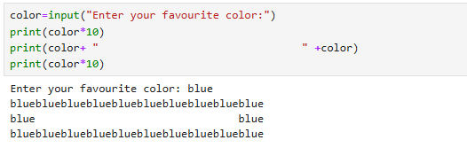

Activity- 4:
Store a person‟s name, and include some „*‟ characters at the beginning and end of the name. Print the name once, so the „*‟ around the name is displayed. Then print the name using each of the three stripping functions, lstrip(), rstrip(), and strip().
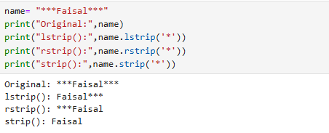

Activity- 5:
Write a function called absolute_num() that accepts one parameter, num. The function should return only positive value, and apply condition on it. This function returns the absolute value of the entered number.
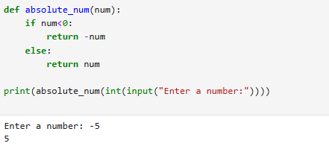

Activity- 6:
Write a function called describe_city( ) that accepts the name of a city and its country. The function should print a simple sentence, such as Karachi is in Pakistan. Give the parameter for the country a default value. Call your function for three different cities, at least one of which is in the default country.
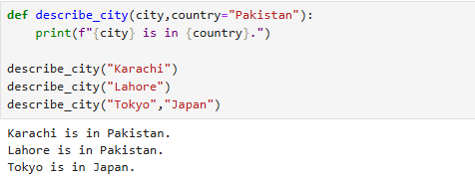

Activity- 7:
Write a python script that take a user input and to create the multiplication table (from 1 to 10) of that number.

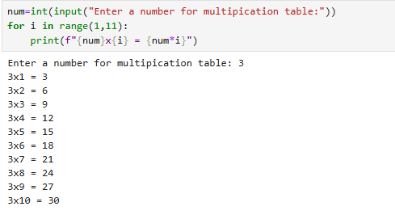

Activity- 8:
Write a Python program that prints all the numbers from 0 to 6 except 3 and 6.
Note: Use 'continue' statement.
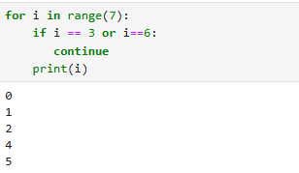

Activity- 9:
Stages of Life: Write an if-elif-else chain that determines a person‟s stage of life. Set a value for the variable age, and then:
- If the person is less than 2 years old, print a message that the person is a baby.
- If the person is at least 4 years old but less than 13, print a message that the person is a kid.
- If the person is at least 13 years old but less than 20, print a message that the person is a teenager.
- If the person is at least 20 years old but less than 65, print a message that the person is an adult.
- If the person is age 65 or older, print a message that the person is an old.
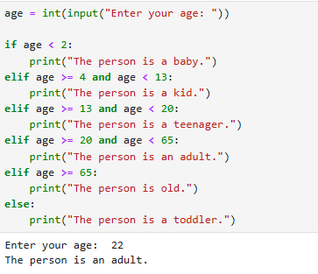

Lab #02
Activity- 1:
Write a Python script that uses a dictionary to store information about a person you know. Store their first name, last name, age, and the city in which they live. You should have keys such as first_name, last_name, age, and city. Print each piece of information stored in your dictionary.
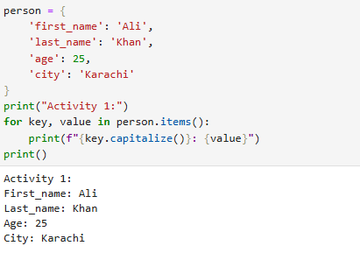

Activity- 2:
Write a function that accepts a dictionary as an argument. If the dictionary contains replicate values, return an empty dictionary, otherwise, return a new dictionary whose values are now the keys and whose keys are the values.
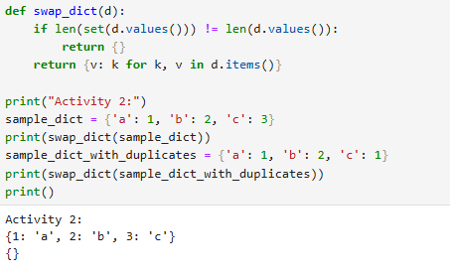

Activity- 3:
A buffet-style restaurant offers only five basic foods. Think of five simple foods, and store them in a tuple.
- Use a for loop to print each food the restaurant offers.
- Try to modify one of the items, and make sure that Python rejects the change.

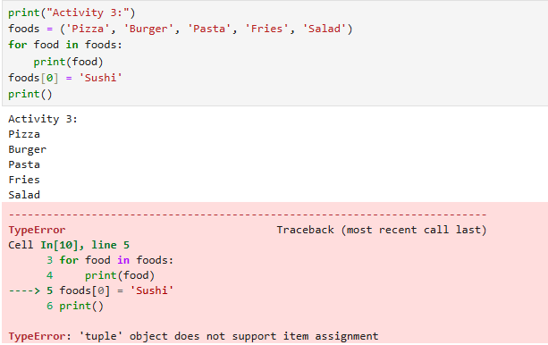

Activity- 4:
If you could invite anyone to dinner. Make a list that includes at least three people you’d like to invite to dinner. Then use your list to print a message to each person, inviting them to dinner.
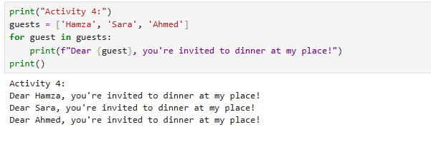

Activity- 5:
Changing Guest List: You just heard that one of your guests can’t make the dinner, so you need to send out a new set of invitations. You’ll have to think of someone else to invite.
- Modify your list, replacing the name of the guest who can’t make it with the name of the new person you are inviting.
- Print a second set of invitation messages, one for each person who is still in your list.
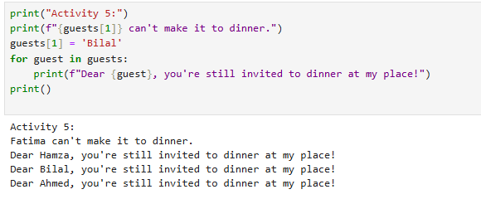

Activity- 6:
Write a program to read 6 numbers and create a dictionary having keys EVEN and ODD.
Dictionary's value should be stored in list. Your dictionary should be like: {'EVEN':[8,10,64], 'ODD':[1,5,9]}
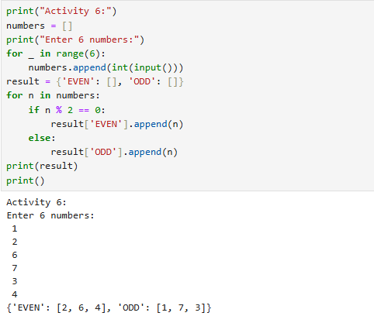

Activity- 7:
Write a definition of a method count_now(places) to find and display those place names, in which there are more than 5 characters.
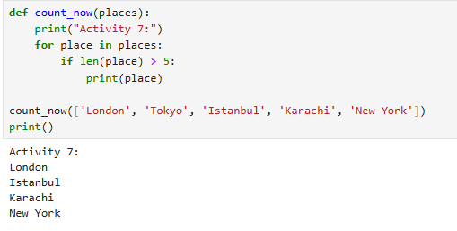

Activity- 8:
Write the following 2 functions: def ComputeOddSum(num): def ComputeEvenSum(num):

- The function ComputeOddSum find the sum of all odd numbers less than num.
- The function ComputeEvenSum find the sum of all even numbers less than num.

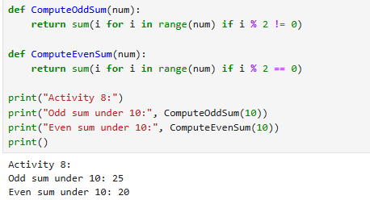

Activity- 9:
Write a recursive function to get sum of all number from 1 up to give number. Example N = 5 Result must be sum (1+2+3+4+5) =15.
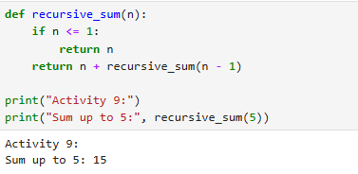

Lab #03

Class Employee
Employee: Parameterized constructor.
getter & setter: Create the get and set method to each attribute. display: Displays Employee ID and Name in the following format: ID: 1234 – Name: XYZ - Salary: 70000.00

Class Faculty
Faculty: Parameterized constructor.
getter & setter: Create the get and set method to each attribute. display: Shows the Faculty information in the following format: ID: 1234 – Name: XYZ – Degree: PhD - Salary: 70000.00 salary: Calculate salary based on the following formula :
Salary= basicSalary + teachingHours * 1000

Class Staff
Staff: Parameterized constructor.
getter & setter: Create the get and set method to each attribute. display: Shows the Staff information in the following format:
ID: 1234 – Name: XYZ – JobTitle: Registrar –Salary: 70000.00

salary: Calculate salary based on the following formula:
Salary= basicSalary
Unless workingHours > 8, Then
Salary=basicSalary+ (basicSalary *25 /100 )

Once you are done implementing the classes, you need to test your work using the class with main method to do the following:
- Create an instance of class Employee, an instance of class Faculty and an instance of class Staff with proper values for the attributes.
- Display the information for each instance using display() method.
- Show the salary for Faculty and Staff.
Run example:
ID: 43221 - Name: Ali - Salary: 70000.0 PKR
ID: 71245 - Name: Majed - Degree: PhD - Teaching hours: 15 - Salary:182000.0 PKR
ID: 81234 - Name: Nasser – Job Title: Registrar – Working hours: 10 - Salary:125000.0 PKR

class Employee:
def __init__(self, emp_id, name, salary):
self.emp_id = emp_id
self.name = name
self.salary = salary

def get_id(self): return self.emp_id
def set_id(self, emp_id): self.emp_id = emp_id

def get_name(self): return self.name
def set_name(self, name): self.name = name

def get_salary(self): return self.salary
def set_salary(self, salary): self.salary = salary

def display(self):
print(f"ID: {self.emp_id} - Name: {self.name} - Salary: {self.salary:.1f} PKR")

class Faculty(Employee):
def __init__(self, emp_id, name, basic_salary, degree, teaching_hours):
self.degree = degree
self.teaching_hours = teaching_hours
salary = basic_salary + teaching_hours * 1000
super().__init__(emp_id, name, salary)

def get_degree(self): return self.degree
def set_degree(self, degree): self.degree = degree

def get_teaching_hours(self): return self.teaching_hours
def set_teaching_hours(self, hours): self.teaching_hours = hours

def display(self):
print(f"ID: {self.emp_id} - Name: {self.name} - Degree: {self.degree} - Teaching hours: {self.teaching_hours} - Salary: {self.salary:.1f} PKR")

class Staff(Employee):
def __init__(self, emp_id, name, basic_salary, job_title, working_hours):
self.job_title = job_title
self.working_hours = working_hours
if working_hours > 8:
salary = basic_salary + (basic_salary * 0.25)
else:
salary = basic_salary
super().__init__(emp_id, name, salary)

def get_job_title(self): return self.job_title
def set_job_title(self, title): self.job_title = title

def get_working_hours(self): return self.working_hours
def set_working_hours(self, hours): self.working_hours = hours

def display(self):
print(f"ID: {self.emp_id} - Name: {self.name} - Job Title: {self.job_title} - Working hours: {self.working_hours} - Salary: {self.salary:.1f} PKR")

if __name__ == "__main__":
emp = Employee(43221, "Ali", 70000)
faculty = Faculty(71245, "Majed", 32000, "PhD", 15)
staff = Staff(81234, "Nasser", 100000, "Registrar", 10)

emp.display()
faculty.display()
staff.display()

Lab #04
Activity- 1:
In contrast to the standard FIFO implementation of Queue, the LifoQueue uses last-in, first-out ordering (normally associated with a stack data structure). Implement LIFO queue using queue module.
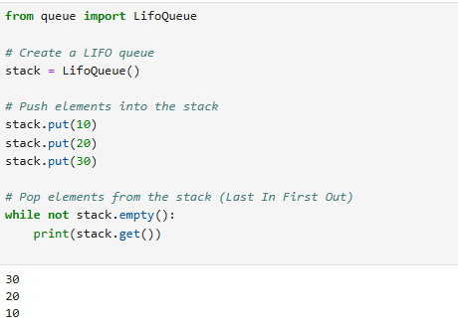

Activity- 2:
We have an array of 5 elements: [4, 8, 1, 7, 3] and we have to insert all the elements in the maxpriority queue. First as the priority queue is empty, so 4 will be inserted initially. Now when 8 will be inserted it will move to front as 8 is greater than 4. While inserting 1, as it is the current minimum element in the priority queue, it will remain in the back of priority queue. Now 7 will be inserted between 8 and 4 as 7 is smaller than 8. Now 3 will be inserted before 1 as it is the 2nd minimum element in the priority queue. All the steps are represented in the diagram below:
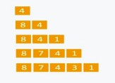

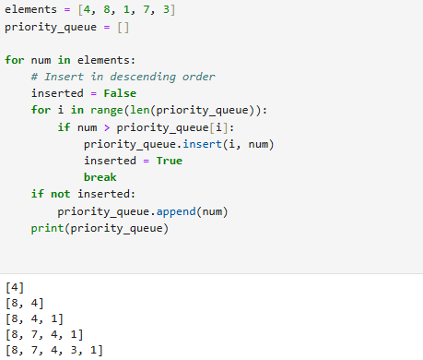



Activity- 3:
Consider a simple priority queue implementation for scheduling the presentations of students based on their roll number. Here roll number decides the priority of the student to present. Since it is a min-heap, roll number 1 is considered to be of the highest priority.
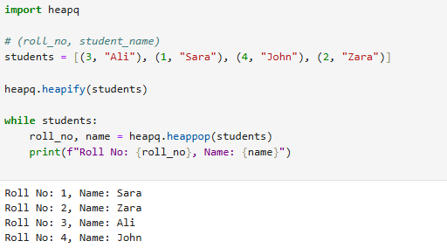

Activity- 4:
Initialize a heap with student marks and their names.
- Print the heap.
- Print the name of students from highest to lowest marks scored by students.

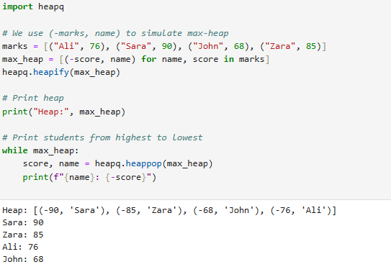

Lab #05

Activity- 1:
Consider the following graph. If there is ever a decision between multiple neighbor nodes in the BFS algorithm, assume we always choose the letter closest to the beginning of the alphabet first. A connected graph with 7 nodes and 7 edges. The edges are undirected and unweight. Distance between two nodes will be measured based on the number of edges separating two vertices. Represent a graph with adjacency list using dictionaries. The keys of the dictionary represent nodes; the values have a list of neighbors.
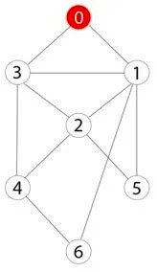

Define function name ‗connected_component‘, this function keep track of all the visited nodes with BFS, is as simple as implementing the steps of the algorithm and assign ‗queue‘ variable already has a node to be checked, i.e., the starting vertex that is used as an entry point to explore the graph. The next step is to implement a loop that keeps cycling until queue is empty. At each iteration of the loop, a node is checked. If this wasn‘t visited already, its neighbors are added to queue. Once the loop is exited, the function (connected_component) returns all of the visited nodes.

from collections import deque

def connected_component(graph, start):
visited = []
queue = deque([start])

while queue:
node = queue.popleft()
if node not in visited:
visited.append(node)
# Get neighbors and sort them alphabetically/numerically to ensure correct order
neighbors = sorted(graph[node])
for neighbor in neighbors:
if neighbor not in visited:
queue.append(neighbor)
return visited

# Updated graph based on the image
graph = {
0: [1, 2, 3],
1: [0, 5],
2: [0, 4, 5, 6],
3: [0, 4],
4: [2, 3],
5: [1, 2],
6: [2]
}

# Starting node for BFS
start_node = 0

# Get the connected component starting from '0'
component = connected_component(graph, start_node)
print("Connected component starting from", start_node, ":", component)

Activity- 2:
Apply Breadth First Search on following graph considering the initial state is 1 and final state is
10. Show results in form of open and closed list. Also evaluate it manually.
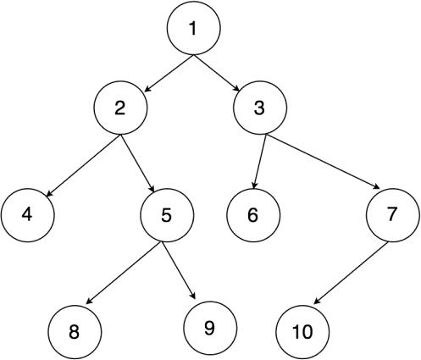
from collections import deque

def bfs_with_open_closed(graph, start, goal):
open_list = deque([start]) # Open list (queue)
closed_list = [] # Closed list (visited nodes)

while open_list:
node = open_list.popleft() # Dequeue the first node
closed_list.append(node) # Add it to the closed list

# Check if the goal is reached
if node == goal:
return open_list, closed_list

# Add neighbors to the open list if not already visited
for neighbor in graph[node]:
if neighbor not in open_list and neighbor not in closed_list:
open_list.append(neighbor)

return open_list, closed_list # Return the lists if goal is not found

# Graph structure based on the image
graph = {
1: [2, 3],
2: [4, 5],
3: [6, 7],
4: [],
5: [8, 9],
6: [],
7: [10],
8: [],
9: [],
10: []
}

# Initial and goal states
start_node = 1
goal_node = 10

# Perform BFS
open_list, closed_list = bfs_with_open_closed(graph, start_node, goal_node)

# Display results
print("Open List:", list(open_list))
print("Closed List:", closed_list)
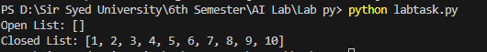

Activity- 3:
Repeat Activity-2, apply BFS by taking initial and final state as user input. Show results in form of open and closed list. Also evaluate it manually.

from collections import deque

def bfs_with_open_closed(graph, start, goal):
open_list = deque([start]) # Open list (queue)
closed_list = [] # Closed list (visited nodes)

while open_list:
node = open_list.popleft() # Dequeue the first node
closed_list.append(node) # Add it to the closed list

# Check if the goal is reached
if node == goal:
return open_list, closed_list

# Add neighbors to the open list if not already visited
for neighbor in graph[node]:
if neighbor not in open_list and neighbor not in closed_list:
open_list.append(neighbor)

return open_list, closed_list # Return the lists if goal is not found

# Graph structure based on the image
graph = {
1: [2, 3],
2: [4, 5],
3: [6, 7],
4: [],
5: [8, 9],
6: [],
7: [10],
8: [],
9: [],
10: []
}

# Take user input for initial and goal states
start_node = int(input("Enter the initial state: "))
goal_node = int(input("Enter the goal state: "))

# Perform BFS
open_list, closed_list = bfs_with_open_closed(graph, start_node, goal_node)

# Display results
print("Open List:", list(open_list))
print("Closed List:", closed_list)
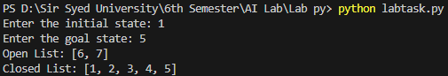

Activity- 4:
Apply Depth First Search on Activity-2 graph considering the initial state is 1 and final state is
10. Show results in form of open and closed list. Also evaluate it manually.

from collections import deque

def bfs_with_open_closed(graph, start, goal):
open_list = deque([start]) # Open list (queue)
closed_list = [] # Closed list (visited nodes)

while open_list:
node = open_list.popleft() # Dequeue the first node
closed_list.append(node) # Add it to the closed list

# Check if the goal is reached
if node == goal:
return open_list, closed_list

# Add neighbors to the open list if not already visited
for neighbor in graph[node]:
if neighbor not in open_list and neighbor not in closed_list:
open_list.append(neighbor)

return open_list, closed_list # Return the lists if goal is not found

def dfs_with_open_closed(graph, start, goal):
open_list = [start] # Open list (stack)
closed_list = [] # Closed list (visited nodes)

while open_list:
node = open_list.pop() # Pop the last node (LIFO)
closed_list.append(node) # Add it to the closed list

# Check if the goal is reached
if node == goal:
return open_list, closed_list

# Add neighbors to the open list if not already visited
for neighbor in reversed(graph[node]): # Reverse to maintain DFS order
if neighbor not in open_list and neighbor not in closed_list:
open_list.append(neighbor)

return open_list, closed_list # Return the lists if goal is not found

# Graph structure based on the image
graph = {
1: [2, 3],
2: [4, 5],
3: [6, 7],
4: [],
5: [8, 9],
6: [],
7: [10],
8: [],
9: [],
10: []
}

# Initial and goal states
start_node = 1
goal_node = 10

# Perform DFS
open_list, closed_list = dfs_with_open_closed(graph, start_node, goal_node)

# Display results
print("DFS Open List:", open_list)
print("DFS Closed List:", closed_list)
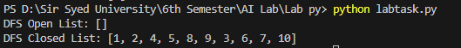

Activity- 5:
Repeat Activity-4, apply DFS by taking initial and final state as user input. Show results in form of open and closed list. Also evaluate it manually.

from collections import deque

def bfs_with_open_closed(graph, start, goal):
open_list = deque([start]) # Open list (queue)
closed_list = [] # Closed list (visited nodes)

while open_list:
node = open_list.popleft() # Dequeue the first node
closed_list.append(node) # Add it to the closed list

# Check if the goal is reached
if node == goal:
return open_list, closed_list

# Add neighbors to the open list if not already visited
for neighbor in graph[node]:
if neighbor not in open_list and neighbor not in closed_list:
open_list.append(neighbor)

return open_list, closed_list # Return the lists if goal is not found

def dfs_with_open_closed(graph, start, goal):
open_list = [start] # Open list (stack)
closed_list = [] # Closed list (visited nodes)

while open_list:
node = open_list.pop() # Pop the last node (LIFO)
closed_list.append(node) # Add it to the closed list

# Check if the goal is reached
if node == goal:
return open_list, closed_list

# Add neighbors to the open list if not already visited
for neighbor in reversed(graph[node]): # Reverse to maintain DFS order
if neighbor not in open_list and neighbor not in closed_list:
open_list.append(neighbor)

return open_list, closed_list # Return the lists if goal is not found

# Graph structure based on the image
graph = {
1: [2, 3],
2: [4, 5],
3: [6, 7],
4: [],
5: [8, 9],
6: [],
7: [10],
8: [],
9: [],
10: []
}

# Take user input for initial and goal states
start_node = int(input("Enter the initial state: "))
goal_node = int(input("Enter the goal state: "))

# Perform DFS
open_list, closed_list = dfs_with_open_closed(graph, start_node, goal_node)

# Display results
print("DFS Open List:", open_list)
print("DFS Closed List:", closed_list)
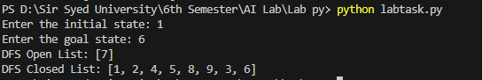

Activity- 6:
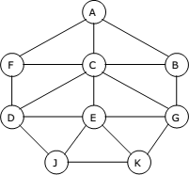
Represent a graph with adjacency list using dictionaries. The keys of the dictionary represent nodes; the values have a list of neighbors. Apply Breadth First Search on following graph considering the initial state is A and final state is K. Also evaluate it manually.

from collections import deque

def bfs_with_open_closed(graph, start, goal):
open_list = deque([start]) # Open list (queue)
closed_list = [] # Closed list (visited nodes)

while open_list:
node = open_list.popleft() # Dequeue the first node
closed_list.append(node) # Add it to the closed list

# Check if the goal is reached
if node == goal:
return open_list, closed_list

# Add neighbors to the open list if not already visited
for neighbor in graph[node]:
if neighbor not in open_list and neighbor not in closed_list:
open_list.append(neighbor)

return open_list, closed_list # Return the lists if goal is not found

# Graph structure based on the image
graph = {
'A': ['B', 'C', 'F'],
'B': ['A', 'G'],
'C': ['A', 'D', 'E'],
'D': ['C', 'F', 'J'],
'E': ['C', 'G', 'J', 'K'],
'F': ['A', 'D'],
'G': ['B', 'E'],
'J': ['D', 'E'],
'K': ['E']
}

# Initial and goal states
start_node = 'A'
goal_node = 'K'

# Perform BFS
open_list, closed_list = bfs_with_open_closed(graph, start_node, goal_node)

# Display results
print("BFS Open List:", list(open_list))
print("BFS Closed List:", closed_list)

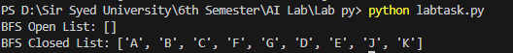

Activity- 7:
Represent a graph with adjacency list using dictionaries. The keys of the dictionary represent nodes; the values have a list of neighbors. Apply Depth First Search on Activity-6 graph considering the initial state is A and final state is K. Also evaluate it manually.

from collections import deque

def bfs_with_open_closed(graph, start, goal):
open_list = deque([start]) # Open list (queue)
closed_list = [] # Closed list (visited nodes)

while open_list:
node = open_list.popleft() # Dequeue the first node
closed_list.append(node) # Add it to the closed list

# Check if the goal is reached
if node == goal:
return open_list, closed_list

# Add neighbors to the open list if not already visited
for neighbor in graph[node]:
if neighbor not in open_list and neighbor not in closed_list:
open_list.append(neighbor)

return open_list, closed_list # Return the lists if goal is not found

def dfs_with_open_closed(graph, start, goal):
open_list = [start] # Open list (stack)
closed_list = [] # Closed list (visited nodes)

while open_list:
node = open_list.pop() # Pop the last node (LIFO)
closed_list.append(node) # Add it to the closed list

# Check if the goal is reached
if node == goal:
return open_list, closed_list

# Add neighbors to the open list if not already visited
for neighbor in reversed(graph[node]): # Reverse to maintain DFS order
if neighbor not in open_list and neighbor not in closed_list:
open_list.append(neighbor)

return open_list, closed_list # Return the lists if goal is not found

# Graph structure based on the image
graph = {
'A': ['B', 'C', 'F'],
'B': ['A', 'G'],
'C': ['A', 'D', 'E'],
'D': ['C', 'F', 'J'],
'E': ['C', 'G', 'J', 'K'],
'F': ['A', 'D'],
'G': ['B', 'E'],
'J': ['D', 'E'],
'K': ['E']
}

# Initial and goal states
start_node = 'A'
goal_node = 'K'

# Perform BFS
open_list, closed_list = bfs_with_open_closed(graph, start_node, goal_node)

# Display results
print("BFS Open List:", list(open_list))
print("BFS Closed List:", closed_list)

# Perform DFS
open_list, closed_list = dfs_with_open_closed(graph, start_node, goal_node)

# Display results
print("DFS Open List:", open_list)
print("DFS Closed List:", closed_list)
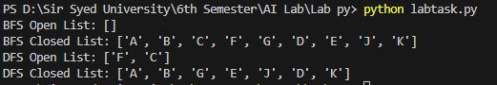

Activity 08:
You need to implement DFS and BFS both using "Pygame" and "Pyamaze" library, generate the maze of (20,20) and find the path.

Implementing BFS using Pyamaze:

from pyamaze import maze,agent,textLabel

def BFS(m):
start=(m.rows,m.cols)
frontier=[start]
explored=[start]
bfsPath={}
while len(frontier)>0:
currCell=frontier.pop(0)
if currCell==(1,1):
break
for d in 'ESNW':
if m.maze_map[currCell][d]==True:
if d=='E':
childCell=(currCell[0],currCell[1]+1)
elif d=='W':
childCell=(currCell[0],currCell[1]-1)
elif d=='N':
childCell=(currCell[0]-1,currCell[1])
elif d=='S':
childCell=(currCell[0]+1,currCell[1])
if childCell in explored:
continue
frontier.append(childCell)
explored.append(childCell)
bfsPath[childCell]=currCell
fwdPath={}
cell=(1,1)
while cell!=start:
fwdPath[bfsPath[cell]]=cell
cell=bfsPath[cell]
return fwdPath

if __name__=='__main__':
m=maze(10 ,10)
m.CreateMaze(loopPercent=100)
path=BFS(m)

a=agent(m,footprints=True)
m.tracePath({a:path})
l=textLabel(m,'Length of Shortest Path',len(path)+1)
print('Length of Shortest Path',len(path)+1)
print(m.maze_map)
m.run()
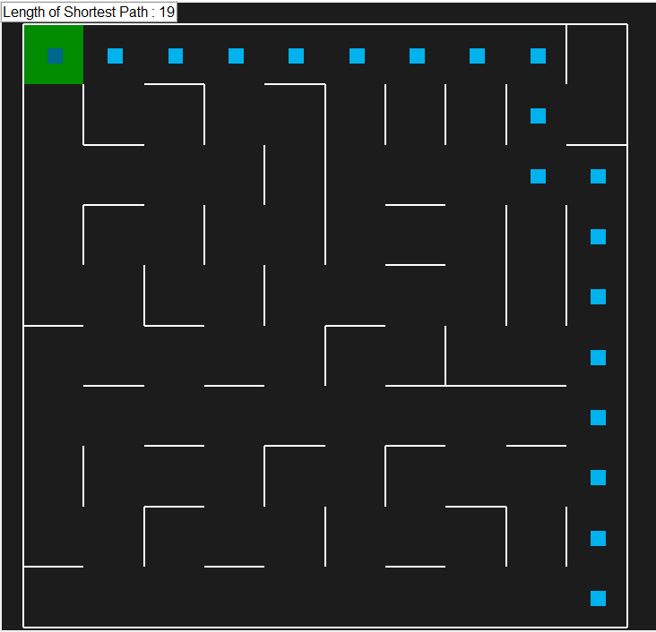

Implementing DFS using Pyamaze:

from pyamaze import maze,agent
def DFS(m):
start=(m.rows,m.cols)
explored=[start]
frontier=[start]
dfsPath={}
while len(frontier)>0:
currCell=frontier.pop()
if currCell==(1,1):
break
for d in 'ESNW':
if m.maze_map[currCell][d]==True:
if d=='E':
childCell=(currCell[0],currCell[1]+1)
elif d=='W':
childCell=(currCell[0],currCell[1]-1)
elif d=='S':
childCell=(currCell[0]+1,currCell[1])
elif d=='N':
childCell=(currCell[0]-1,currCell[1])
if childCell in explored:
continue
explored.append(childCell)
frontier.append(childCell)
dfsPath[childCell]=currCell
fwdPath={}
cell=(1,1)
while cell!=start:
fwdPath[dfsPath[cell]]=cell
cell=dfsPath[cell]
return fwdPath

if __name__=='__main__':
m=maze(10 ,10) #Setting maze 10 X 10
m.CreateMaze() # Now creating maze of soze 10 x 10
path=DFS(m) #calling method DFS which is returning path
a=agent(m,footprints=True) #player declaration
m.tracePath({a:path}) #tracing path by agent

# print({a:path})
m.run() #Execution
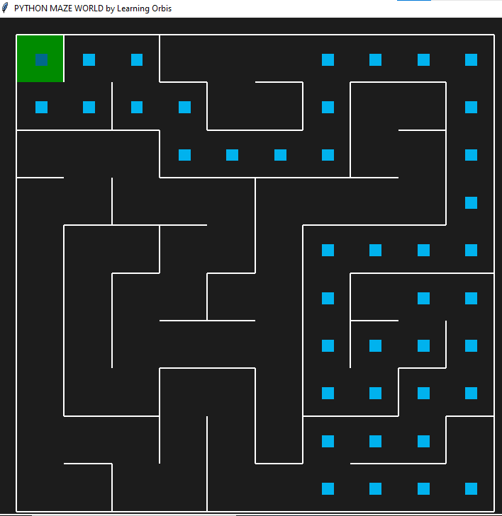

Implementing DFS using Pygame:

import pygame
import time

# Initialize Pygame
pygame.init()

# Screen dimensions
SCREEN_WIDTH = 800
SCREEN_HEIGHT = 600
CELL_SIZE = 40 # Size of each cell in the grid

# Colors
WHITE = (255, 255, 255)
BLACK = (0, 0, 0)
RED = (255, 0, 0)
BLUE = (0, 0, 255)
GREEN = (0, 255, 0)

# Create the screen
screen = pygame.display.set_mode((SCREEN_WIDTH, SCREEN_HEIGHT))
pygame.display.set_caption("DFS Visualization")

# Maze dimensions
ROWS = 10
COLS = 10

# Create a grid-based maze (1 = open, 0 = wall)
maze = [
[1, 1, 0, 0, 0, 0, 0, 0, 0, 0],
[0, 1, 1, 1, 0, 0, 0, 0, 0, 0],
[0, 0, 0, 1, 0, 0, 0, 0, 0, 0],
[0, 0, 0, 1, 1, 1, 1, 1, 0, 0],
[0, 0, 0, 0, 0, 0, 0, 1, 0, 0],
[0, 0, 0, 0, 0, 0, 0, 1, 1, 1],
[0, 0, 0, 0, 0, 0, 0, 0, 0, 1],
[0, 0, 0, 0, 0, 0, 0, 0, 0, 1],
[0, 0, 0, 0, 0, 0, 0, 0, 0, 1],
[0, 0, 0, 0, 0, 0, 0, 0, 0, 1],
]

# DFS algorithm
def dfs(maze, start, goal):
stack = [start]
visited = set()
path = {}

while stack:
current = stack.pop()
if current == goal:
break
visited.add(current)

for direction in [(0, 1), (1, 0), (0, -1), (-1, 0)]: # Right, Down, Left, Up
next_cell = (current[0] + direction[0], current[1] + direction[1])
if (
0 <= next_cell[0] < ROWS
and 0 <= next_cell[1] < COLS
and next_cell not in visited
and maze[next_cell[0]][next_cell[1]] == 1
):
stack.append(next_cell)
path[next_cell] = current

# Reconstruct the path
full_path = []
cell = goal
while cell != start:
full_path.append(cell)
cell = path[cell]
full_path.append(start)
full_path.reverse()
return full_path

# Draw the maze
def draw_maze(maze, path, player_pos):
for row in range(ROWS):
for col in range(COLS):
color = WHITE if maze[row][col] == 1 else BLACK
pygame.draw.rect(
screen,
color,
(col * CELL_SIZE, row * CELL_SIZE, CELL_SIZE, CELL_SIZE),
)
pygame.draw.rect(
screen, BLACK, (col * CELL_SIZE, row * CELL_SIZE, CELL_SIZE, CELL_SIZE), 1
)

# Draw the path
for cell in path:
pygame.draw.rect(
screen,
BLUE,
(cell[1] * CELL_SIZE, cell[0] * CELL_SIZE, CELL_SIZE, CELL_SIZE),
)

# Draw the player
pygame.draw.rect(
screen,
RED,
(player_pos[1] * CELL_SIZE, player_pos[0] * CELL_SIZE, CELL_SIZE, CELL_SIZE),
)

# Main function
def main():
start = (0, 0)
goal = (9, 9)
path = dfs(maze, start, goal)
player_pos = start

run = True
clock = pygame.time.Clock()

while run:
screen.fill(BLACK)
draw_maze(maze, path, player_pos)

for event in pygame.event.get():
if event.type == pygame.QUIT:
run = False
elif event.type == pygame.KEYDOWN:
if event.key == pygame.K_w: # Move up
next_pos = (player_pos[0] - 1, player_pos[1])
elif event.key == pygame.K_s: # Move down
next_pos = (player_pos[0] + 1, player_pos[1])
elif event.key == pygame.K_a: # Move left
next_pos = (player_pos[0], player_pos[1] - 1)
elif event.key == pygame.K_d: # Move right
next_pos = (player_pos[0], player_pos[1] + 1)
else:
next_pos = player_pos

# Check if the move is valid
if (
0 <= next_pos[0] < ROWS
and 0 <= next_pos[1] < COLS
and maze[next_pos[0]][next_pos[1]] == 1
):
player_pos = next_pos

pygame.display.update()
clock.tick(60)

pygame.quit()

if __name__ == "__main__":
main()

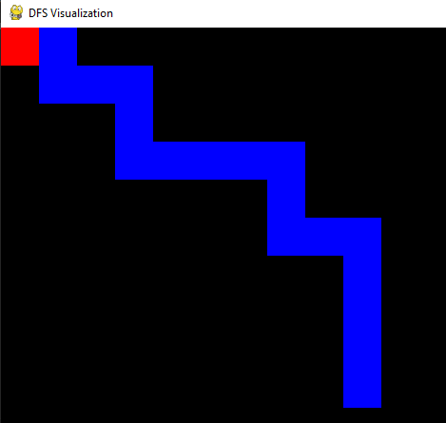

Implementing BFS using Pygame:

import pygame
from collections import deque

# Initialize Pygame
pygame.init()

# Screen dimensions
SCREEN_WIDTH = 800
SCREEN_HEIGHT = 600
CELL_SIZE = 40 # Size of each cell in the grid

# Colors
WHITE = (255, 255, 255)
BLACK = (0, 0, 0)
RED = (255, 0, 0)
BLUE = (0, 0, 255)
GREEN = (0, 255, 0)

# Create the screen
screen = pygame.display.set_mode((SCREEN_WIDTH, SCREEN_HEIGHT))
pygame.display.set_caption("BFS Visualization")

# Maze dimensions
ROWS = 10
COLS = 10

# Create a grid-based maze (1 = open, 0 = wall)
maze = [
[1, 1, 0, 0, 0, 0, 0, 0, 0, 0],
[0, 1, 1, 1, 0, 0, 0, 0, 0, 0],
[0, 0, 0, 1, 0, 0, 0, 0, 0, 0],
[0, 0, 0, 1, 1, 1, 1, 1, 0, 0],
[0, 0, 0, 0, 0, 0, 0, 1, 0, 0],
[0, 0, 0, 0, 0, 0, 0, 1, 1, 1],
[0, 0, 0, 0, 0, 0, 0, 0, 0, 1],
[0, 0, 0, 0, 0, 0, 0, 0, 0, 1],
[0, 0, 0, 0, 0, 0, 0, 0, 0, 1],
[0, 0, 0, 0, 0, 0, 0, 0, 0, 1],
]

# BFS algorithm
def bfs(maze, start, goal):
queue = deque([start])
visited = set()
visited.add(start)
path = {}

while queue:
current = queue.popleft()
if current == goal:
break

for direction in [(0, 1), (1, 0), (0, -1), (-1, 0)]: # Right, Down, Left, Up
next_cell = (current[0] + direction[0], current[1] + direction[1])
if (
0 <= next_cell[0] < ROWS
and 0 <= next_cell[1] < COLS
and next_cell not in visited
and maze[next_cell[0]][next_cell[1]] == 1
):
queue.append(next_cell)
visited.add(next_cell)
path[next_cell] = current

# Reconstruct the path
full_path = []
cell = goal
while cell != start:
full_path.append(cell)
cell = path[cell]
full_path.append(start)
full_path.reverse()
return full_path

# Draw the maze
def draw_maze(maze, path, player_pos):
for row in range(ROWS):
for col in range(COLS):
color = WHITE if maze[row][col] == 1 else BLACK
pygame.draw.rect(
screen,
color,
(col * CELL_SIZE, row * CELL_SIZE, CELL_SIZE, CELL_SIZE),
)
pygame.draw.rect(
screen, BLACK, (col * CELL_SIZE, row * CELL_SIZE, CELL_SIZE, CELL_SIZE), 1
)

# Draw the path
for cell in path:
pygame.draw.rect(
screen,
BLUE,
(cell[1] * CELL_SIZE, cell[0] * CELL_SIZE, CELL_SIZE, CELL_SIZE),
)

# Draw the player
pygame.draw.rect(
screen,
RED,
(player_pos[1] * CELL_SIZE, player_pos[0] * CELL_SIZE, CELL_SIZE, CELL_SIZE),
)

# Main function
def main():
start = (0, 0)
goal = (9, 9)
path = bfs(maze, start, goal)
player_pos = start

run = True
clock = pygame.time.Clock()

while run:
screen.fill(BLACK)
draw_maze(maze, path, player_pos)

for event in pygame.event.get():
if event.type == pygame.QUIT:
run = False
elif event.type == pygame.KEYDOWN:
if event.key == pygame.K_w: # Move up
next_pos = (player_pos[0] - 1, player_pos[1])
elif event.key == pygame.K_s: # Move down
next_pos = (player_pos[0] + 1, player_pos[1])
elif event.key == pygame.K_a: # Move left
next_pos = (player_pos[0], player_pos[1] - 1)
elif event.key == pygame.K_d: # Move right
next_pos = (player_pos[0], player_pos[1] + 1)
else:
next_pos = player_pos

# Check if the move is valid
if (
0 <= next_pos[0] < ROWS
and 0 <= next_pos[1] < COLS
and maze[next_pos[0]][next_pos[1]] == 1
):
player_pos = next_pos

pygame.display.update()
clock.tick(60)

pygame.quit()

if __name__ == "__main__":
main()
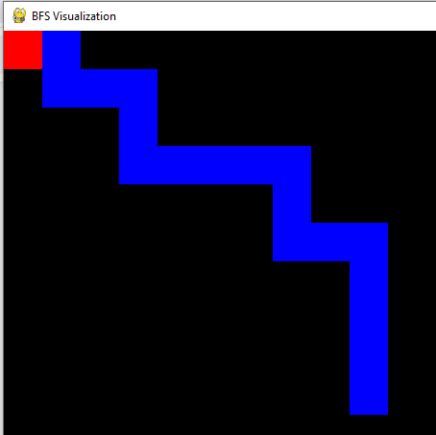

Lab #06

Activity- 1:
Implement A* search in the following state graph, find the shortest path between node S to Node
G. Also solve it manually.
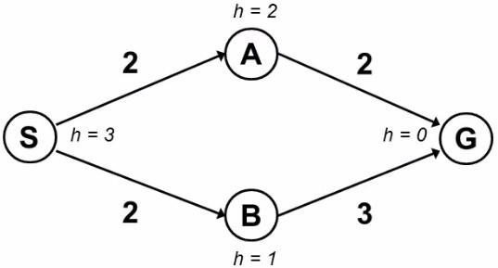

from collections import deque
import heapq

def bfs_with_open_closed(graph, start, goal):
open_list = deque([start]) # Open list (queue)
closed_list = [] # Closed list (visited nodes)

while open_list:
node = open_list.popleft() # Dequeue the first node
closed_list.append(node) # Add it to the closed list

# Check if the goal is reached
if node == goal:
return open_list, closed_list

# Add neighbors to the open list if not already visited
for neighbor in graph[node]:
if neighbor not in open_list and neighbor not in closed_list:
open_list.append(neighbor)

return open_list, closed_list # Return the lists if goal is not found

def dfs_with_open_closed(graph, start, goal):
open_list = [start] # Open list (stack)
closed_list = [] # Closed list (visited nodes)

while open_list:
node = open_list.pop() # Pop the last node (LIFO)
closed_list.append(node) # Add it to the closed list

# Check if the goal is reached
if node == goal:
return open_list, closed_list

# Add neighbors to the open list if not already visited
for neighbor in reversed(graph[node]): # Reverse to maintain DFS order
if neighbor not in open_list and neighbor not in closed_list:
open_list.append(neighbor)

return open_list, closed_list # Return the lists if goal is not found

def a_star_search(graph, heuristic, start, goal):
open_list = [] # Priority queue for open list
heapq.heappush(open_list, (0 + heuristic[start], start)) # (f(n), node)
closed_list = [] # Closed list (visited nodes)
g_costs = {start: 0} # Cost from start to each node
came_from = {} # To reconstruct the path

while open_list:
_, current = heapq.heappop(open_list) # Get the node with the lowest f(n)
closed_list.append(current)

# Check if the goal is reached
if current == goal:
path = reconstruct_path(came_from, current)
return path, closed_list

# Explore neighbors
for neighbor, cost in graph[current]:
tentative_g_cost = g_costs[current] + cost
if neighbor not in g_costs or tentative_g_cost < g_costs[neighbor]:
g_costs[neighbor] = tentative_g_cost
f_cost = tentative_g_cost + heuristic[neighbor]
heapq.heappush(open_list, (f_cost, neighbor))
came_from[neighbor] = current

return None, closed_list # Return None if no path is found

def reconstruct_path(came_from, current):
path = [current]
while current in came_from:
current = came_from[current]
path.append(current)
path.reverse()
return path

# Graph structure based on the image
graph_bfs_dfs = {
'A': ['B', 'C', 'F'],
'B': ['A', 'G'],
'C': ['A', 'D', 'E'],
'D': ['C', 'F', 'J'],
'E': ['C', 'G', 'J', 'K'],
'F': ['A', 'D'],
'G': ['B', 'E'],
'J': ['D', 'E'],
'K': ['E']
}

# Graph structure with edge costs
graph_a_star = {
'S': [('A', 2), ('B', 2)],
'A': [('G', 2)],
'B': [('G', 3)],
'G': []
}

# Heuristic values for each node
heuristic = {
'S': 3,
'A': 2,
'B': 1,
'G': 0
}

# Initial and goal states for BFS and DFS
start_node_bfs_dfs = 'A'
goal_node_bfs_dfs = 'K'

# Perform BFS
open_list, closed_list = bfs_with_open_closed(graph_bfs_dfs, start_node_bfs_dfs, goal_node_bfs_dfs)

# Display results
print("BFS Open List:", list(open_list))
print("BFS Closed List:", closed_list)

# Perform DFS
open_list, closed_list = dfs_with_open_closed(graph_bfs_dfs, start_node_bfs_dfs, goal_node_bfs_dfs)

# Display results
print("DFS Open List:", open_list)
print("DFS Closed List:", closed_list)

# Initial and goal states for A* Search
start_node_a_star = 'S'
goal_node_a_star = 'G'

# Perform A* Search
path, closed_list = a_star_search(graph_a_star, heuristic, start_node_a_star, goal_node_a_star)

# Display results
print("Shortest Path:", path)
print("Closed List:", closed_list)
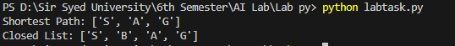

Activity- 2:
Implement A* search in the following state graph, find the shortest path between node ‘s’ to node ‘c’ or ‘d’. Also solve it manually.
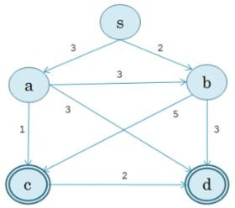

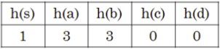

import heapq

def a_star_search(graph, heuristic, start, goals):
open_list = [] # Priority queue for open list
heapq.heappush(open_list, (0 + heuristic[start], start)) # (f(n), node)
closed_list = [] # Closed list (visited nodes)
g_costs = {start: 0} # Cost from start to each node
came_from = {} # To reconstruct the path

while open_list:
_, current = heapq.heappop(open_list) # Get the node with the lowest f(n)
closed_list.append(current)

# Check if the goal is reached
if current in goals:
path = reconstruct_path(came_from, current)
return path, closed_list

# Explore neighbors
for neighbor, cost in graph[current]:
tentative_g_cost = g_costs[current] + cost
if neighbor not in g_costs or tentative_g_cost < g_costs[neighbor]:
g_costs[neighbor] = tentative_g_cost
f_cost = tentative_g_cost + heuristic[neighbor]
heapq.heappush(open_list, (f_cost, neighbor))
came_from[neighbor] = current

return None, closed_list # Return None if no path is found

def reconstruct_path(came_from, current):
path = [current]
while current in came_from:
current = came_from[current]
path.append(current)
path.reverse()
return path

# Graph structure with edge costs
graph = {
's': [('a', 3), ('b', 2)],
'a': [('c', 3), ('d', 5)],
'b': [('a', 3), ('d', 3)],
'c': [],
'd': []
}

# Heuristic values for each node
heuristic = {
's': 1,
'a': 3,
'b': 3,
'c': 0,
'd': 0
}

# Initial and goal states
start_node = 's'
goal_nodes = ['c', 'd'] # Multiple goals

# Perform A* Search
path, closed_list = a_star_search(graph, heuristic, start_node, goal_nodes)

# Display results
print("Shortest Path:", path)
print("Closed List:", closed_list)
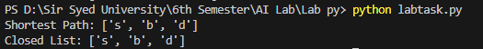

Activity- 3:
Implement A* search in the following state graph, find the shortest path between node ‘a’ to node ‘z’. Also solve it manually.

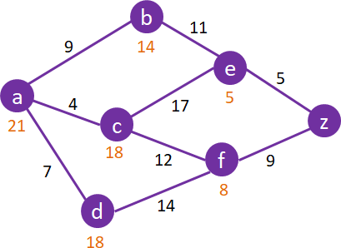

import heapq

def a_star_search(graph, heuristic, start, goal):
open_list = [] # Priority queue for open list
heapq.heappush(open_list, (0 + heuristic[start], start)) # (f(n), node)
closed_list = [] # Closed list (visited nodes)
g_costs = {start: 0} # Cost from start to each node
came_from = {} # To reconstruct the path

while open_list:
_, current = heapq.heappop(open_list) # Get the node with the lowest f(n)
closed_list.append(current)

# Check if the goal is reached
if current == goal:
path = reconstruct_path(came_from, current)
return path, closed_list

# Explore neighbors
for neighbor, cost in graph[current]:
tentative_g_cost = g_costs[current] + cost
if neighbor not in g_costs or tentative_g_cost < g_costs[neighbor]:
g_costs[neighbor] = tentative_g_cost
f_cost = tentative_g_cost + heuristic[neighbor]
heapq.heappush(open_list, (f_cost, neighbor))
came_from[neighbor] = current

return None, closed_list # Return None if no path is found

def reconstruct_path(came_from, current):
path = [current]
while current in came_from:
current = came_from[current]
path.append(current)
path.reverse()
return path

# Graph structure with edge costs
graph = {
'a': [('b', 9), ('c', 4), ('d', 7)],
'b': [('e', 11)],
'c': [('b', 17), ('f', 12)],
'd': [('c', 14), ('f', 14)],
'e': [('z', 5)],
'f': [('e', 8), ('z', 9)],
'z': []
}

# Heuristic values for each node
heuristic = {
'a': 21,
'b': 14,
'c': 18,
'd': 18,
'e': 5,
'f': 8,
'z': 0
}

# Initial and goal states
start_node = 'a'
goal_node = 'z'

# Perform A* Search
path, closed_list = a_star_search(graph, heuristic, start_node, goal_node)

# Display results
print("Shortest Path:", path)
print("Closed List:", closed_list)

Activity- 4:
Implement A* search in the following state graph, find the shortest path between node Arad to Node Bucharest. Also solve it manually.
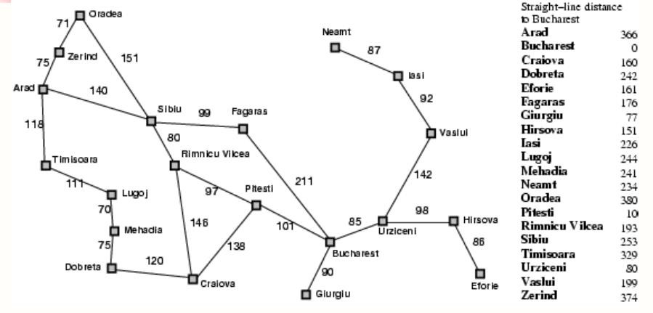

import heapq

def a_star_search(graph, heuristic, start, goal):

open_list = [] # Priority queue for open list

heapq.heappush(open_list, (0 + heuristic[start], start)) # (f(n), node)

closed_list = [] # Closed list (visited nodes)

g_costs = {start: 0} # Cost from start to each node

came_from = {} # To reconstruct the path

while open_list:

_, current = heapq.heappop(open_list) # Get the node with the lowest f(n)

closed_list.append(current)

# Check if the goal is reached

if current == goal:

path = reconstruct_path(came_from, current)

return path, closed_list

# Explore neighbors

for neighbor, cost in graph[current]:

tentative_g_cost = g_costs[current] + cost

if neighbor not in g_costs or tentative_g_cost < g_costs[neighbor]:

g_costs[neighbor] = tentative_g_cost

f_cost = tentative_g_cost + heuristic[neighbor]

heapq.heappush(open_list, (f_cost, neighbor))

came_from[neighbor] = current

return None, closed_list # Return None if no path is found

def reconstruct_path(came_from, current):

path = [current]

while current in came_from:

current = came_from[current]

path.append(current)

path.reverse()

return path

# Graph structure with edge costs

graph = {

'Arad': [('Zerind', 75), ('Sibiu', 140), ('Timisoara', 118)],

'Zerind': [('Arad', 75), ('Oradea', 71)],

'Oradea': [('Zerind', 71), ('Sibiu', 151)],

'Sibiu': [('Arad', 140), ('Oradea', 151), ('Fagaras', 99), ('Rimnicu Vilcea', 80)],

'Timisoara': [('Arad', 118), ('Lugoj', 111)],

'Lugoj': [('Timisoara', 111), ('Mehadia', 70)],

'Mehadia': [('Lugoj', 70), ('Drobeta', 75)],

'Drobeta': [('Mehadia', 75), ('Craiova', 120)],

'Craiova': [('Drobeta', 120), ('Rimnicu Vilcea', 146), ('Pitesti', 138)],

'Rimnicu Vilcea': [('Sibiu', 80), ('Craiova', 146), ('Pitesti', 97)],

'Fagaras': [('Sibiu', 99), ('Bucharest', 211)],

'Pitesti': [('Rimnicu Vilcea', 97), ('Craiova', 138), ('Bucharest', 101)],

'Bucharest': [('Fagaras', 211), ('Pitesti', 101), ('Giurgiu', 90), ('Urziceni', 85)],

'Giurgiu': [('Bucharest', 90)],

'Urziceni': [('Bucharest', 85), ('Hirsova', 98), ('Vaslui', 142)],

'Hirsova': [('Urziceni', 98), ('Eforie', 86)],

'Eforie': [('Hirsova', 86)],

'Vaslui': [('Urziceni', 142), ('Iasi', 92)],

'Iasi': [('Vaslui', 92), ('Neamt', 87)],

'Neamt': [('Iasi', 87)]

}

# Heuristic values for each node (straight-line distance to Bucharest)

heuristic = {

'Arad': 366,

'Bucharest': 0,

'Craiova': 160,

'Drobeta': 242,

'Eforie': 161,

'Fagaras': 176,

'Giurgiu': 77,

'Hirsova': 151,

'Iasi': 226,

'Lugoj': 244,

'Mehadia': 241,

'Neamt': 234,

'Oradea': 380,

'Pitesti': 100,

'Rimnicu Vilcea': 193,

'Sibiu': 253,

'Timisoara': 329,

'Urziceni': 80,

'Vaslui': 199,

'Zerind': 374

}

# Initial and goal states

start_node = 'Arad'

goal_node = 'Bucharest'

# Perform A* Search

path, closed_list = a_star_search(graph, heuristic, start_node, goal_node)

# Display results

print("Shortest Path:", path)

print("Closed List:", closed_list)

Activity- 5:
Implement Greedy Best First Search in the following state graph, find the shortest path between node ‘A’ to Node ‘G’. Also solve it manually.
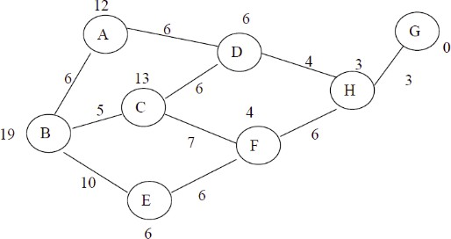

import heapq

def greedy_best_first_search(graph, heuristic, start, goal):

open_list = [] # Priority queue for open list

heapq.heappush(open_list, (heuristic[start], start)) # (h(n), node)

closed_list = [] # Closed list (visited nodes)

came_from = {} # To reconstruct the path

while open_list:

_, current = heapq.heappop(open_list) # Get the node with the lowest h(n)

closed_list.append(current)

# Check if the goal is reached

if current == goal:

path = reconstruct_path(came_from, current)

return path, closed_list

# Explore neighbors

for neighbor, cost in graph[current]:

if neighbor not in closed_list:

heapq.heappush(open_list, (heuristic[neighbor], neighbor))

came_from[neighbor] = current

return None, closed_list # Return None if no path is found

def reconstruct_path(came_from, current):

path = [current]

while current in came_from:

current = came_from[current]

path.append(current)

path.reverse()

return path

# Graph structure with edge costs

graph = {

'A': [('B', 6), ('D', 6)],

'B': [('A', 6), ('C', 5), ('E', 10)],

'C': [('B', 5), ('D', 13), ('F', 7)],

'D': [('A', 6), ('C', 13), ('H', 4)],

'E': [('B', 10), ('F', 6)],

'F': [('C', 7), ('E', 6), ('H', 4)],

'H': [('D', 4), ('F', 6), ('G', 3)],

'G': [('H', 3)]

}

# Heuristic values for each node

heuristic = {

'A': 12,

'B': 19,

'C': 13,

'D': 6,

'E': 10,

'F': 7,

'H': 3,

'G': 0

}

# Initial and goal states

start_node = 'A'

goal_node = 'G'

# Perform Greedy Best-First Search

path, closed_list = greedy_best_first_search(graph, heuristic, start_node, goal_node)

# Display results

print("Shortest Path:", path)

print("Closed List:", closed_list)

Activity- 6:
Implement Best First Search in the following state graph, find the shortest path between node ‘S’ to Node ‘G’. Also solve it manually.
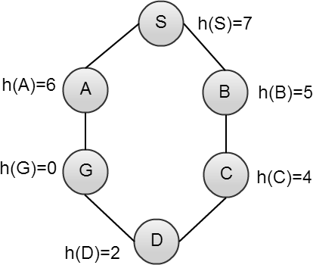

import heapq

def best_first_search(graph, heuristic, start, goal):
open_list = [] # Priority queue for open list
heapq.heappush(open_list, (heuristic[start], start)) # (h(n), node)
closed_list = [] # Closed list (visited nodes)
came_from = {} # To reconstruct the path

while open_list:
_, current = heapq.heappop(open_list) # Get the node with the lowest h(n)
closed_list.append(current)

# Check if the goal is reached
if current == goal:
path = reconstruct_path(came_from, current)
return path, closed_list

# Explore neighbors
for neighbor, cost in graph[current]:
if neighbor not in closed_list:
heapq.heappush(open_list, (heuristic[neighbor], neighbor))
came_from[neighbor] = current

return None, closed_list # Return None if no path is found

def reconstruct_path(came_from, current):
path = [current]
while current in came_from:
current = came_from[current]
path.append(current)
path.reverse()
return path

# Graph structure with edge costs
graph = {
'S': [('A', 1), ('B', 1)],
'A': [('S', 1), ('G', 1)],
'B': [('S', 1), ('C', 1)],
'C': [('B', 1), ('D', 1)],
'D': [('C', 1), ('G', 1)],
'G': [('A', 1), ('D', 1)]
}

# Heuristic values for each node
heuristic = {
'S': 7,
'A': 6,
'B': 5,
'C': 4,
'D': 2,
'G': 0
}

# Initial and goal states
start_node = 'S'
goal_node = 'G'

# Perform Best-First Search
path, closed_list = best_first_search(graph, heuristic, start_node, goal_node)

# Display results
print("Shortest Path:", path)
print("Closed List:", closed_list)

Lab #08

Activity- 1:
Convert following sentences in to PROLOG FACTS and specify whether they represent RELATIONSHIP or PROPERTY:

Declarative Sentence | PROLOG FACT | RELATIONSHIP or  PROPERTY
SSUET is university | university(ssuet). | % Property
Faheem likes ice-cream | likes(faheem, icecream). | % Relationship
Birds can fly | can_fly(bird). | % Property
Switch is off | off(switch). | % Property
Sara is nephew of Saima | nephew(sara, saima). | % Relationship
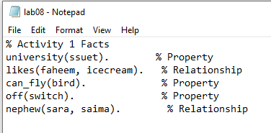

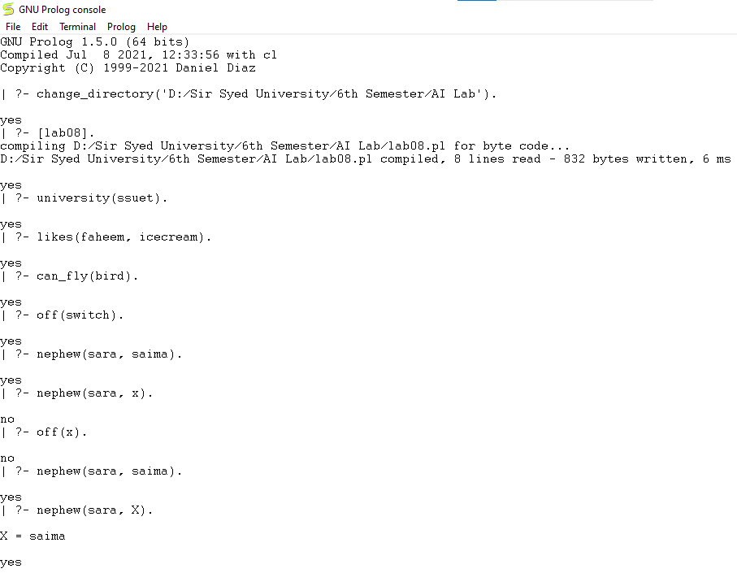

Activity- 2:
Make prolog facts from following sentences and answer the questions by typing queries on prolog.
• Saleem is father of Aslam.
• Dania is mother of Aslam.
• Aslam and Saeed are brothers.
• Faiza is sister of Ali.
• Sana is enemy of Sumra.
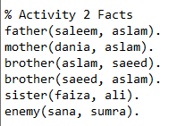

Questions
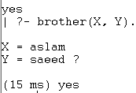
1. List brothers.

2. Who is father of Aslam?
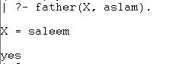

3. Dania is mother of whom?
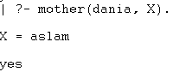

4. Who is brother of Aslam?
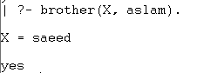

5. Faiza is sister of whom?
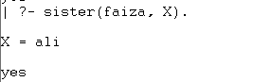

Activity- 3:
Create a file and write below fact and execute this using below question.
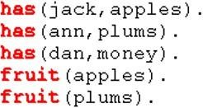

Questions
1. List fruits.
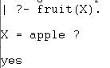

2. Which fruit does Jack have?
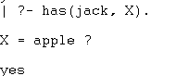

3. Does Dan have something?
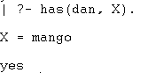

4. Who has apples and who has plums?
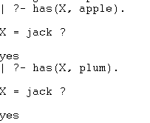

5. Does someone have apples and plums?
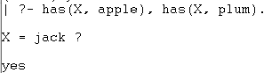

6. Does Dan have fruits?
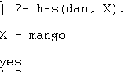

Activity- 4:
Write down the PROLOG Rules for the following sentences:
Declarative Sentences | PROLOG RULES
Person1 is sibling of Person2 if Person3 is parent of Person1 and Person3 is parent of Person2. | sibling(Person1, Person2) :- parent(Person3, Person1), parent(Person3, Person2), Person1 \= Person2.
Person1 is child of Person2 if Person2 is parent of Person1. | child(Person1, Person2) :- parent(Person2, Person1).
It will rain today if clouds are heavy and air pressure is low. | rain_today :- heavy_clouds, low_air_pressure.

Activity- 5:
A person gets good grades if he studies well and is regular in class. Write program in prolog to check whether a given person gets good grade or not?
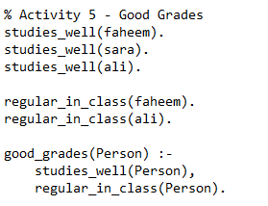

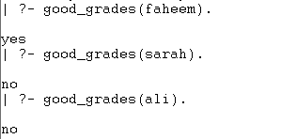

Activity- 6:
Here are some declarative sentences convert them into PROLOG facts and answer following questions.
• Kashif likes music.
• Kashif likes cricket.
• Saba likes chips.
• Saba likes mobile.
• Kashif hates cold drinks.
• Saba hates driving.
• Saba hates parties.
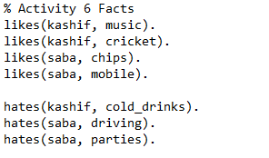

Questions
1. Does Saba like chips?
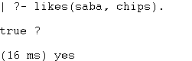

2. Does Kashif hate cricket?
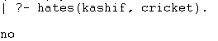

3. Does Kashif like music?
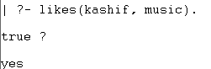

4. What does Kashif like?
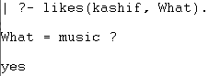

5. What does Saba like?
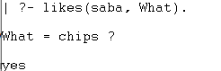

6. Who likes music?
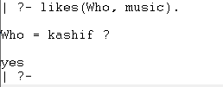

Activity- 7:
There is a cricket team of 5 players; capabilities of each of theplayer are given in following table.
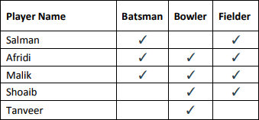

Write the facts from the above table and create the rule for all Rounder and run following goals in PROLOG.
1. Is Afridi all-rounder?
2. Is Shoaib all-rounder?
3. Who are all-rounders in the team?

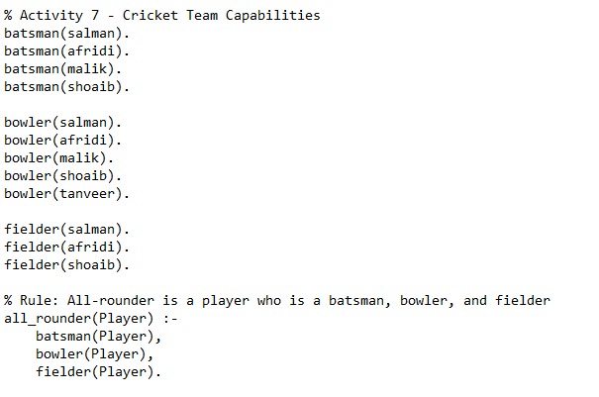

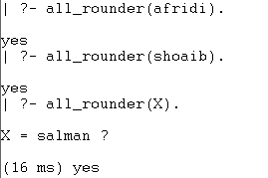

Activity- 8:
Case Study: Family Tree: Consider the following family tree shown in figure below
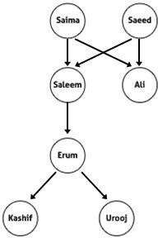

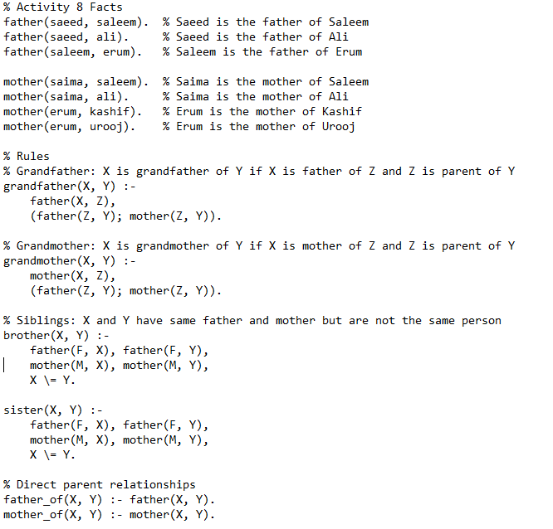
Questions:
1. Is Saleem father of Ali?
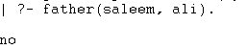

2. Is Kashif brother of Urooj?
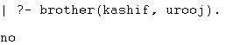

3. Who is father of Kashif?
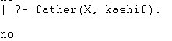

4. Is Erum mother of Urooj?
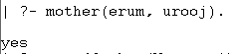

5. Who is grandfather of Urooj?
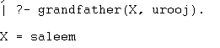
6. Is Salma grandmother of Erum?
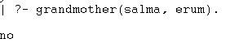

7. Saeed is father of whom?
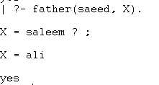

8. Salma is mother of whom?
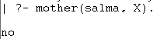

Activity- 9:
Create selection criteria using rules.
1. starter(soup).
2. starter(salad).
3. main_course(rice).
4. main_course(pizza).
5. main_course(burger).
6. desert(custard).
7. desert(ice_cream).
Create rules for hungry, very_hungry and on_diet.
• For hungry: only starter and main course
• For very_hungry starter, main course and desert
• For on_diet it displays only starters.
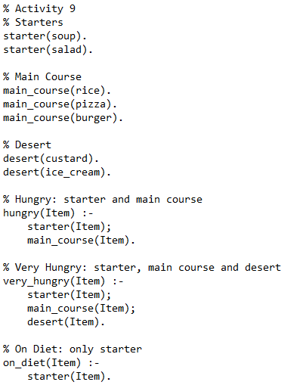



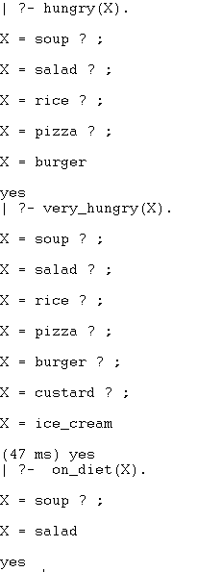

Activity- 10:
Write a program that doubles any number that is taken from user as input.
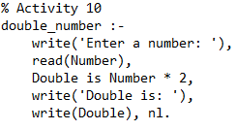

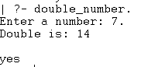

Activity- 11:
Calculate Arithmetic mean of any three numbers.

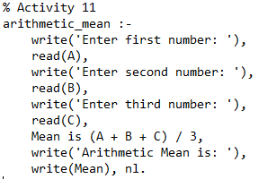

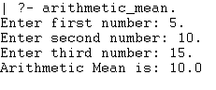
Activity- 12:
Create a basic calculator prolog program for making basic calculations (add, subtract, multiply, divide, average). Use separate goal statements for making each calculation (with constant numeric values).

% Activity 12
% Addition
add :-
write('Enter first number: '), read(A),
write('Enter second number: '), read(B),
Result is A + B,
write('Addition: '), write(Result), nl.

% Subtraction
subtract :-
write('Enter first number: '), read(A),
write('Enter second number: '), read(B),
Result is A - B,
write('Subtraction: '), write(Result), nl.

% Multiplication
multiply :-
write('Enter first number: '), read(A),
write('Enter second number: '), read(B),
Result is A * B,
write('Multiplication: '), write(Result), nl.

% Division
divide :-
write('Enter numerator: '), read(A),
write('Enter denominator: '), read(B),
( B =\= 0
-> Result is A / B,
write('Division: '), write(Result), nl
; write('Error: Division by zero is not allowed.'), nl
).

% Average of three numbers
average :-
write('Enter first number: '), read(A),
write('Enter second number: '), read(B),
write('Enter third number: '), read(C),
Avg is (A + B + C) / 3,
write('Average: '), write(Avg), nl.
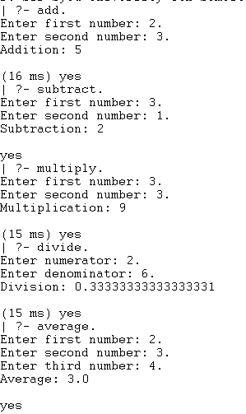

Activity- 13:
Make a calculator program by using write() and read() predicates, for taking numeric input from user and displaying text after program execution.
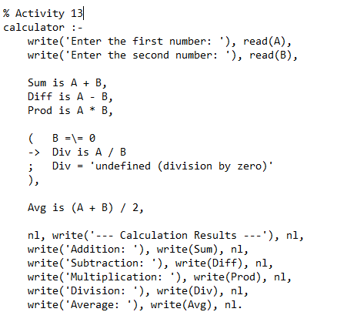

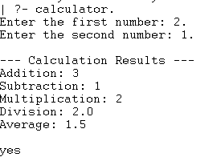

Lab #07
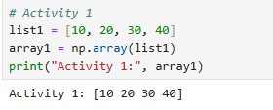
Activity- 1: Write a Python program to convert a list of numeric value into a one-dimensional NumPy array.

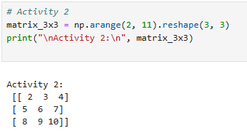
Activity- 2: Create a 3x3 matrix with values ranging from 2 to 11.

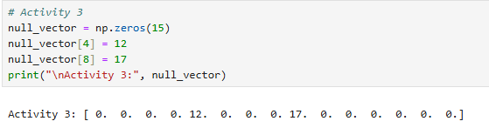
Activity- 3: Create a null vector of size 15 and update fifth value to 12 and ninth value to 17.

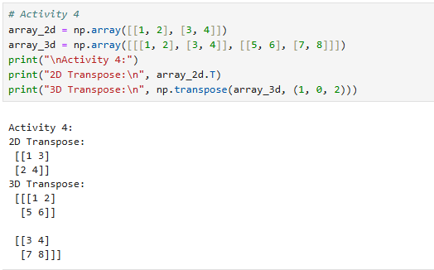
Activity- 4: Take 2D and 3D array and perform transpose function.

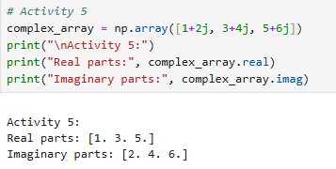
Activity- 5: Write a Python program to find the real and imaginary parts of an array of complex numbers.

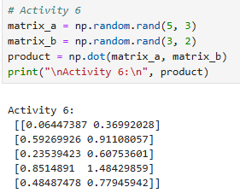
Activity- 6: Multiply a 5x3 matrix by a 3x2 matrix create a real matrix product using dot ( ).

Activity- 7: Create array by 2x3 and perform following function:
- Number of dimensions
- Total number of element/size in an array
- What type of array stores in memory(dtype)
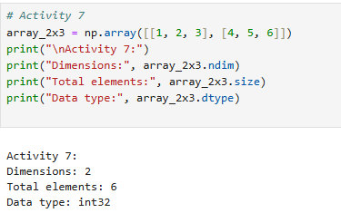

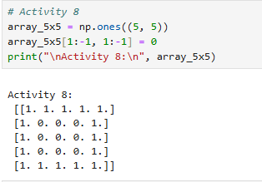
Activity- 8: Write a Python program to create a 2-D array with reshape (5, 5) and filled 1 on the border and 0 inside using slicing method.



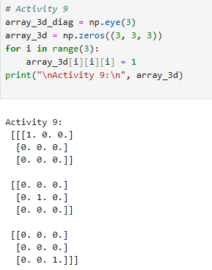
Activity- 9: Write a Python program to create a 3-D array with ones on the diagonal and zeros elsewhere.

Activity- 10: Write a Python program to find common values between two arrays using intersect1d ( ). Take array1= [ 1 30 40 60 80, 90] and array2= [50,10,30,40] as input.
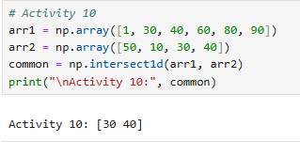
Table A-11: Financial data of a company
Date | Open | High | Low | Close
10-03-22 | 774.25 | 776.065002 | 769.5 | 772.559998
10-04-22 | 776.030029 | 778.710022 | 772.890015 | 776.429993
10-05-22 | 779.309998 | 782.070007 | 775.650024 | 776.469971
10-06-22 | 779 | 780.47998 | 775.539978 | 776.859985
10-07-22 | 779.659973 | 779.659973 | 770.75 | 775.080017

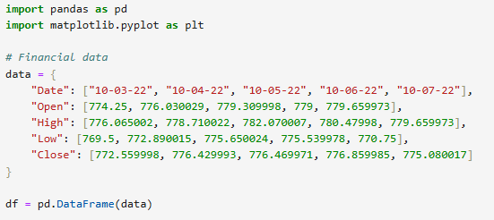

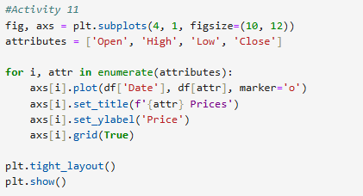
Activity- 11: Write a Python program to draw individual line charts of the financial data of a company given in Table A-11 between October 3, 2022 to October 7, 2022 using subplot for each attribute

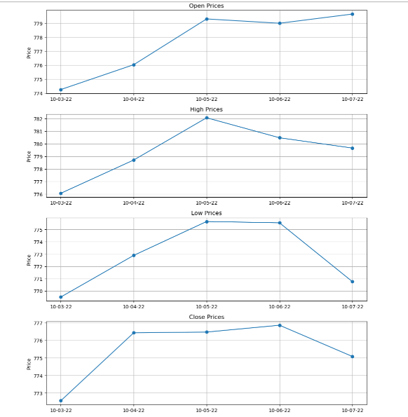

Activity- 12: Write a Python program to draw line charts on the same graph of the financial data of a company given in Table A-11.
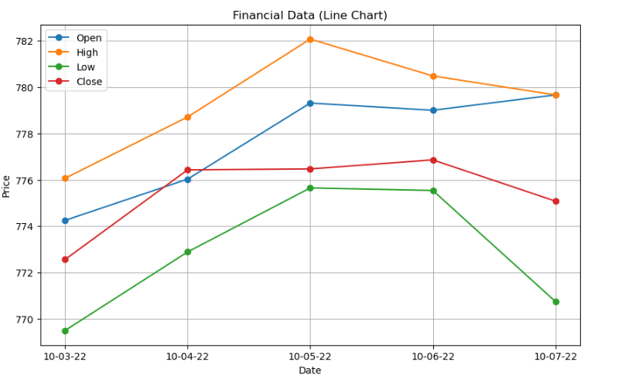
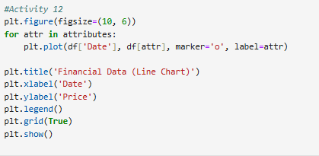

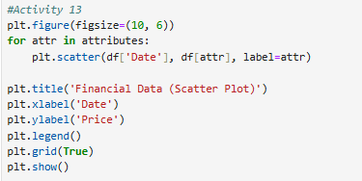
Activity- 13: Write a Python program to draw scatter plot graph of the financial data of a company given in Table A-11.

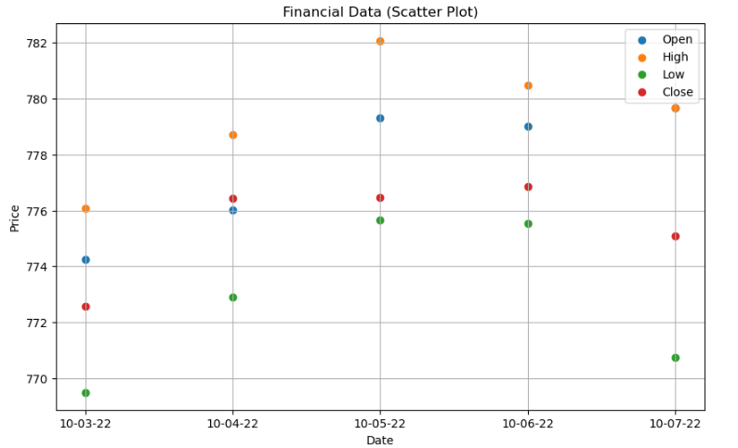

Activity- 14: Write a Python program to draw bar graphs for each attribute of the financial data of a company given in Table A-11.
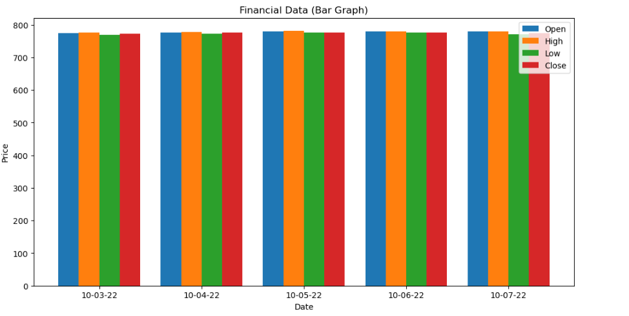
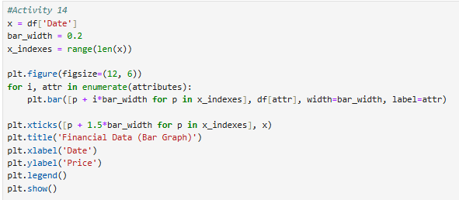

Activity- 15: Write a Python program to draw pie chart for each attribute of the financial data of a company given in Table A-11.
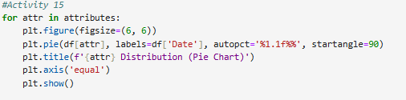

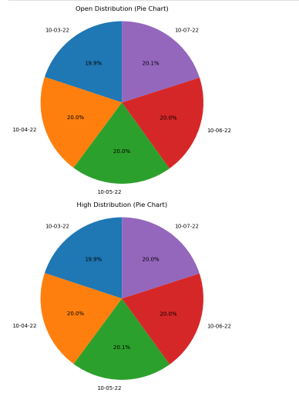

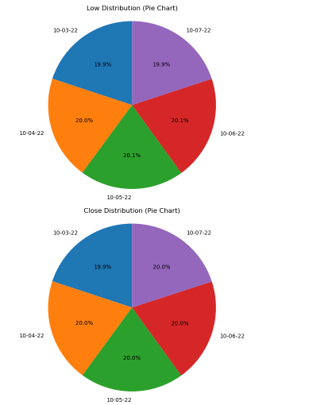

Lab #10

Activity- 1: Consider the dataset given below, implement K-Means Clustering algorithm using K=2. Find out new centroid values based on the mean values of the coordinates of all the data instances from the corresponding cluster. Also find the accuracy of the model and compute it manually.

S. No. | A | B
1 | 170 | 56
2 | 168 | 60
3 | 185 | 72
4 | 188 | 77
5 | 177 | 76
6 | 180 | 71

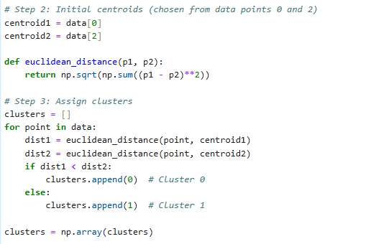
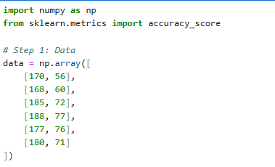

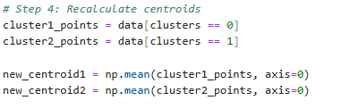

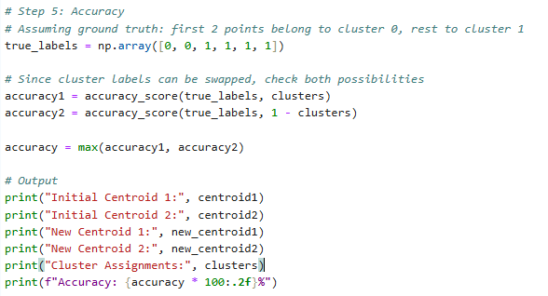

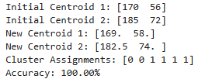

Activity- 2: A dataset (income.csv) has been provided. Implement K-Means Clustering Algorithm on this dataset using K (number of clusters = 3). Find out new centroid values based on the mean values of the coordinates of all the data instances from the corresponding cluster. Also find the accuracy of the model.
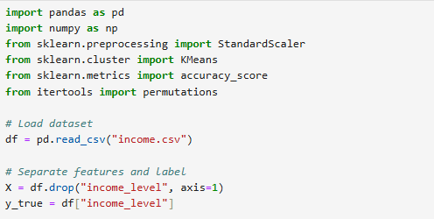

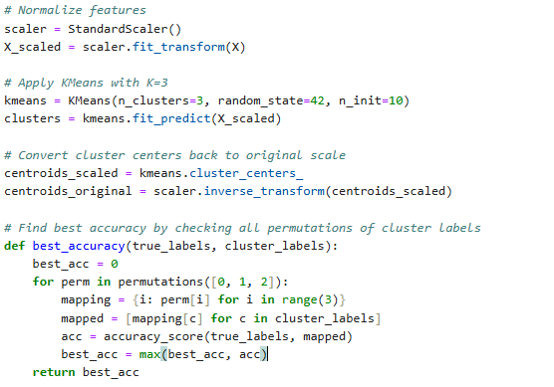



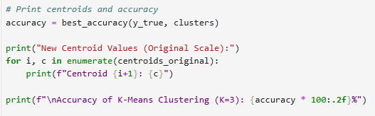

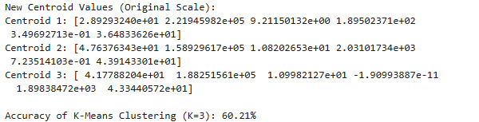

Activity- 3: A dataset (ratings_small.csv) has been provided. Implement K-Means Clustering Algorithm on this dataset using K (number of clusters = 5). Find out new centroid values based on the mean values of the coordinates of all the data instances from the corresponding cluster. Also find the accuracy of the model.
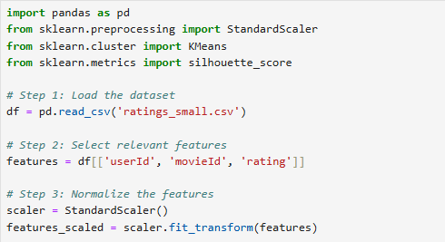

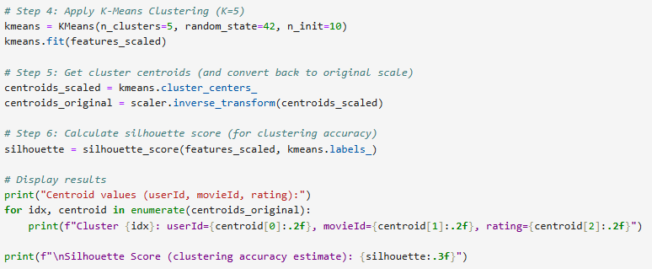



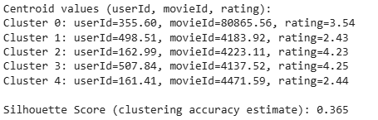

Lab #09

Activity- 1:
Implement the Decision tree algorithm on the data given in the table 9.1 and predict whether the players can play or not when the weather is overcast and the temperature is mild. Also verify results by solving manually.

Table 9.1 Weather Forecast
Weather | Temperature | Play
Sunny | Hot | Yes
Sunny | Hot | Yes
Overcast | Hot | No
Rain | Mild | Yes
Sunny | Cool | No
Overcast | Cool | No
Rain | Mild | Yes
Rain | Mild | Yes
Overcast | Hot | No
Sunny | Hot | No
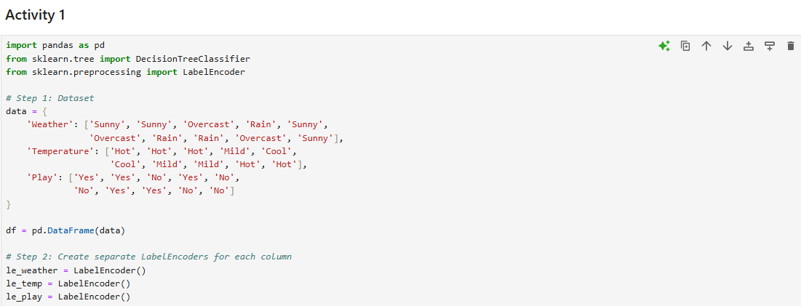

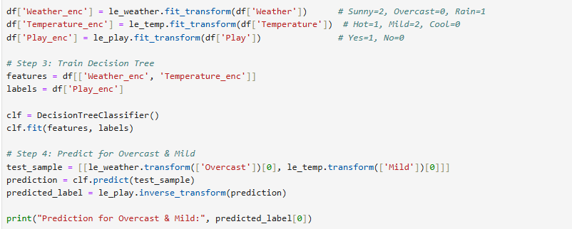

Activity- 2:
Implement the Decision tree algorithm on any dataset taken from Kaggle.com and predict the new entry entered by the user.
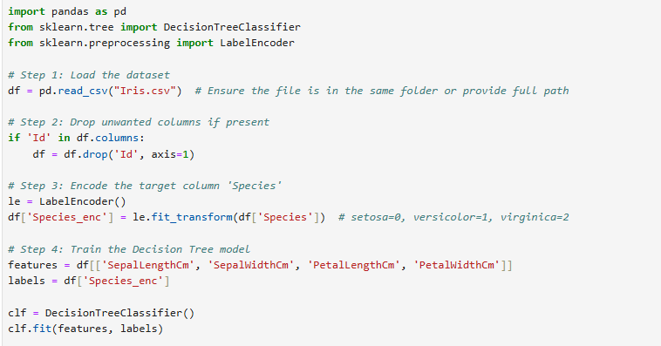

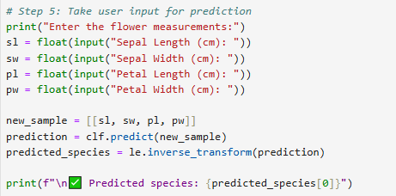

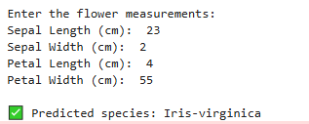

Activity- 3:
Implement Naïve Bayes Algorithm on the dataset given in Table 9.2, to predict whether the players can play or not when the Outlook is Rain, Temperature is Cool, Humidity is High and the Wind is Strong. Also verify results by solving manually.

Table 9.2 Golf play chart
Day | Outlook | Temperature | Humidity | Wind | Play golf
D1 | Sunny | Hot | High | Weak | Yes
D2 | Sunny | Hot | High | Strong | Yes
D3 | Overcast | Hot | High | Weak | No
D4 | Rain | Mild | High | Weak | Yes
D5 | Sunny | Cool | Normal | Weak | No
D6 | Overcast | Cool | Normal | Strong | Yes
D7 | Rain | Mild | Normal | Strong | No
D8 | Rain | Mild | High | Weak | Yes
D9 | Overcast | Hot | Normal | Weak | No
D10 | Sunny | Hot | Normal | Strong | No
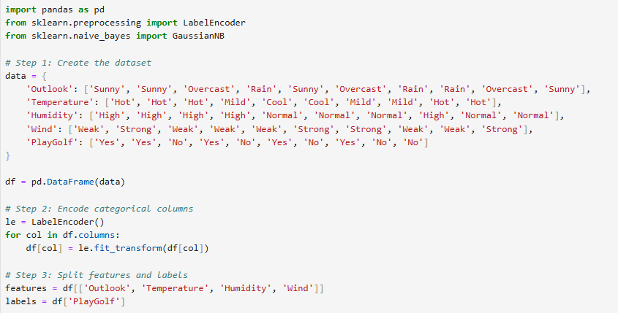

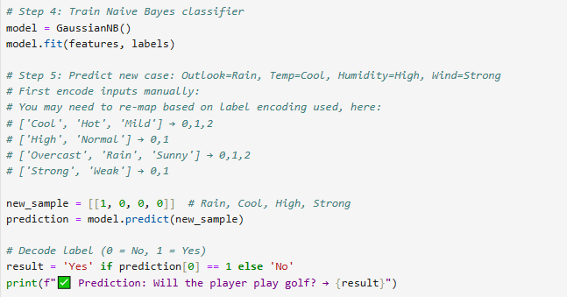

Activity- 4:
Consider the following dataset given in Table 9.3. Implement Naïve Bayes Algorithm to classify youth/medium/yes/fair. Also verify results by solving manually.
Table 9.3 Student income chart
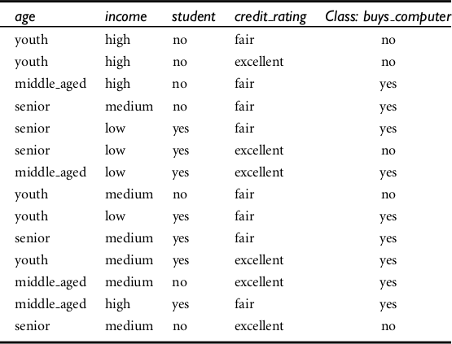

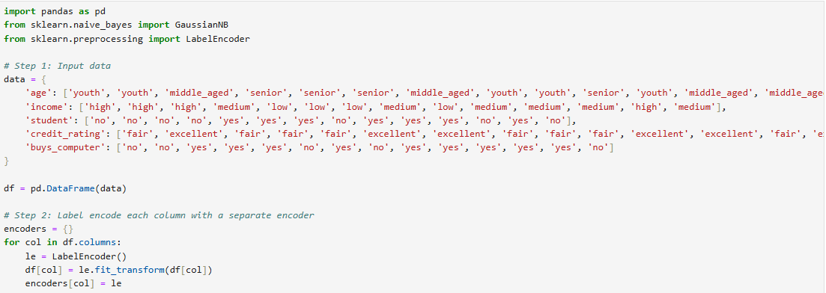

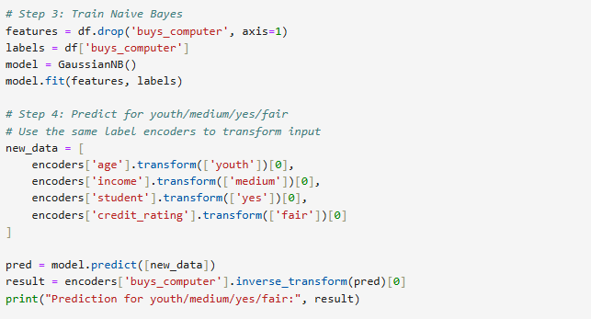

Activity- 5:
Implement the Naïve Bayes algorithm on any dataset taken from Kaggle.com and predict the new entry entered by the user.
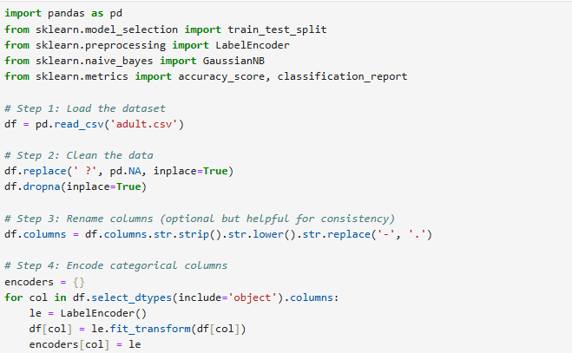

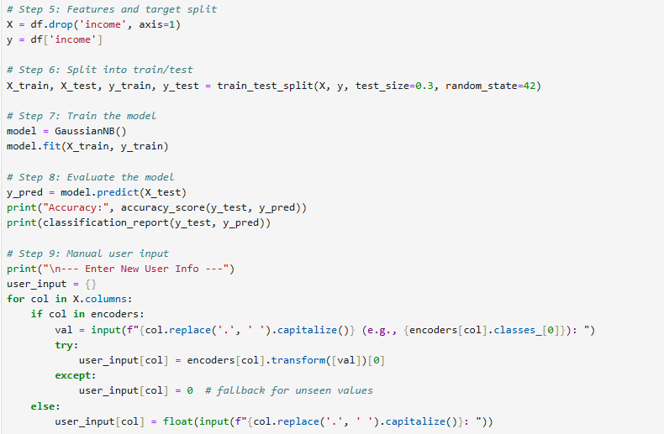

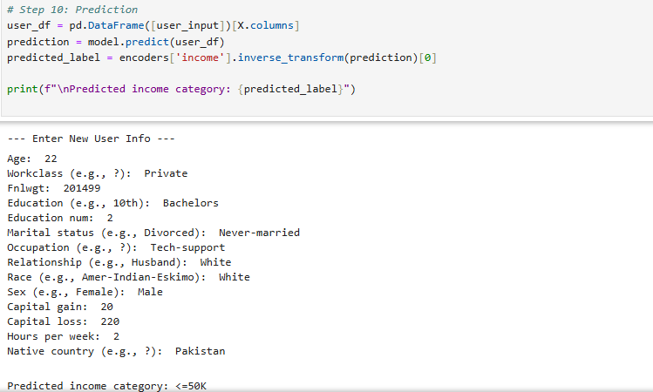

Lab #11

Activity- 1:
The Modified National Institute of Standards and Technology (MNIST) database includes a dataset that contains approximately 60,000 training images and 10,000 testing images of handwritten digits. Implement Artificial Neural Network (ANN) to train neural network, and then use the test dataset to look at its accuracy. Finally, give your own handwritten digit to check the predictions by trained model.
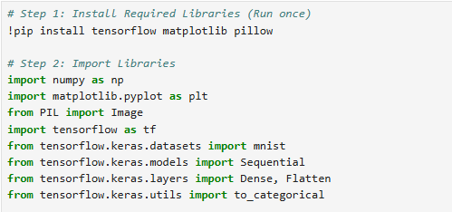

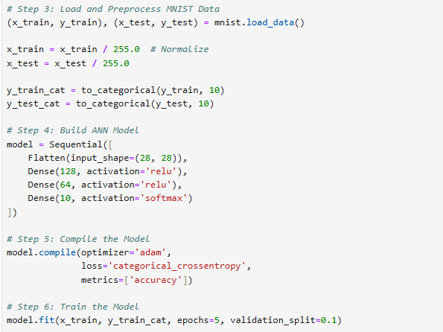

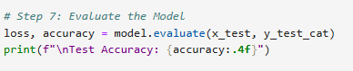

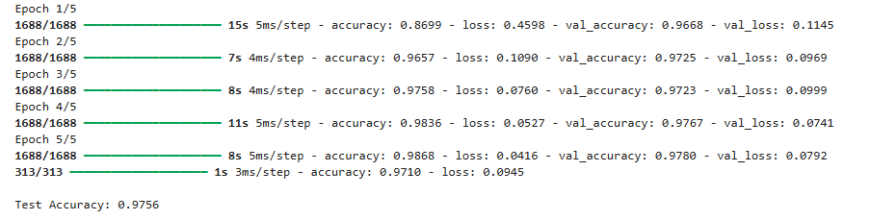

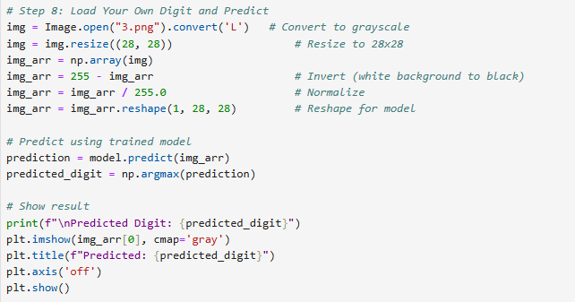

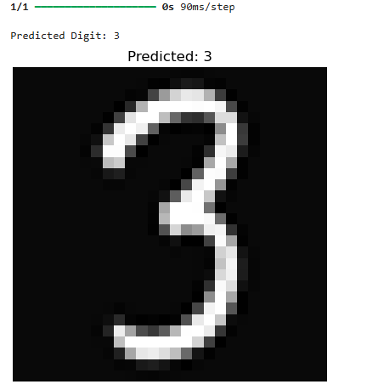

Activity- 2:
Use Convolutional Neural Network (CNN) to do handwritten digits classification using MNIST dataset. We already use ANN for digit classification. You need to modify the code to use CNN. Check how accuracy improve fast by CNN and figure out how CNN can be a better choice for doing image classification compared to ANN. Shows the result by comparing Confusion Matrix and Classification report.
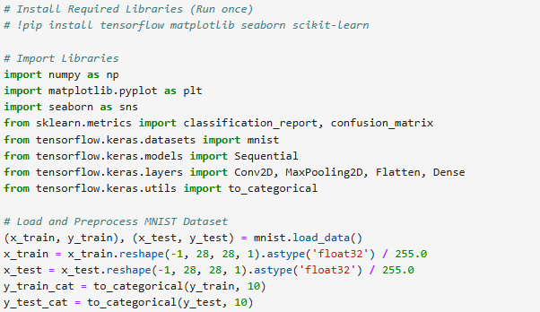

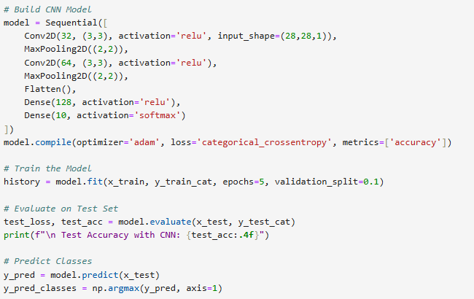

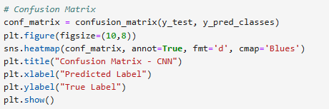

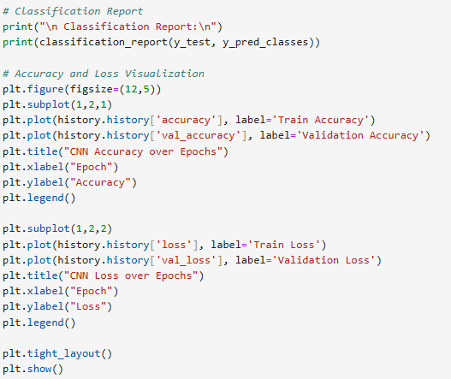

Activity- 3:
Implement Artificial Neural Network (ANN) on CIFAR10 dataset.

Activity- 4:
Implement Convolutional Neural Network (CNN) on CIFAR10 dataset.

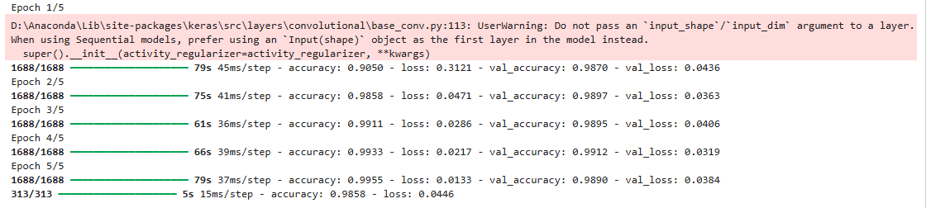


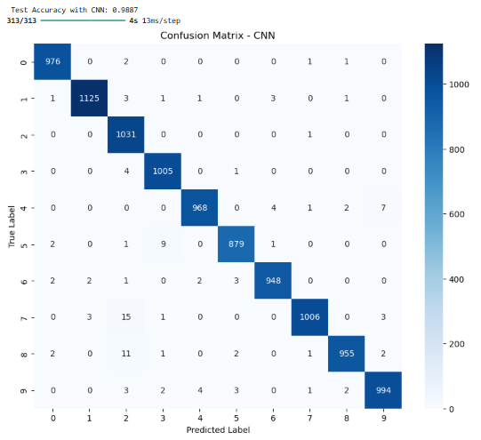

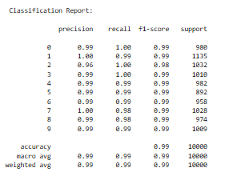

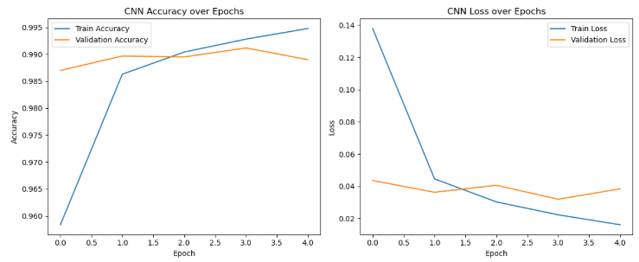

Activity- 3:
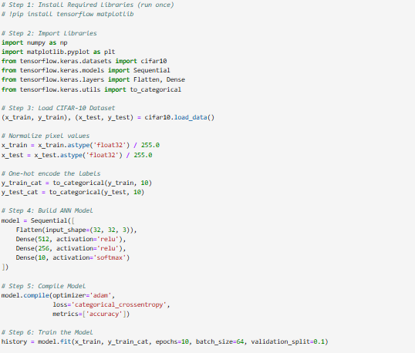
Implement Artificial Neural Network (ANN) on CIFAR10 dataset.



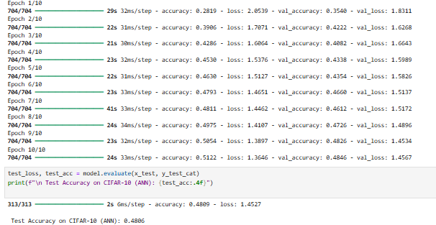

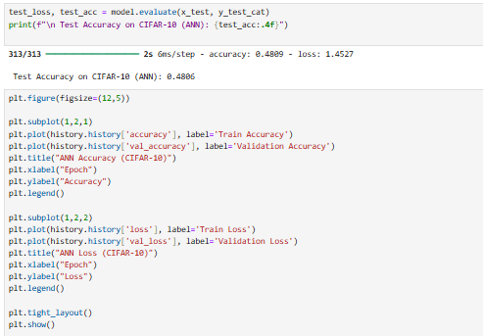

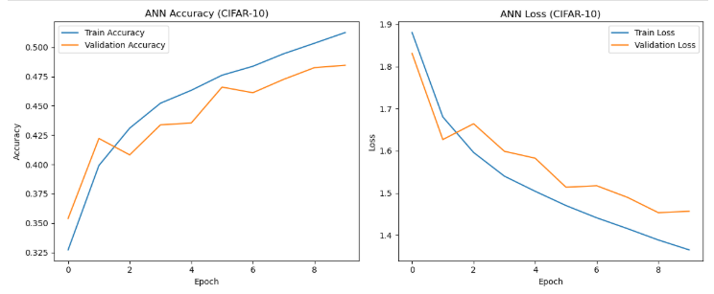

Activity- 4:
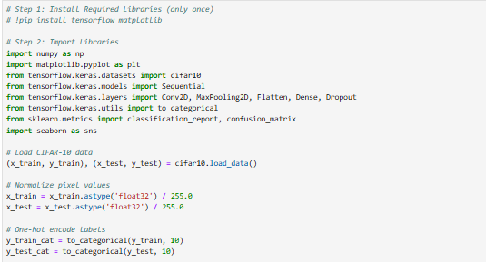
Implement Convolutional Neural Network (CNN) on CIFAR10 dataset.

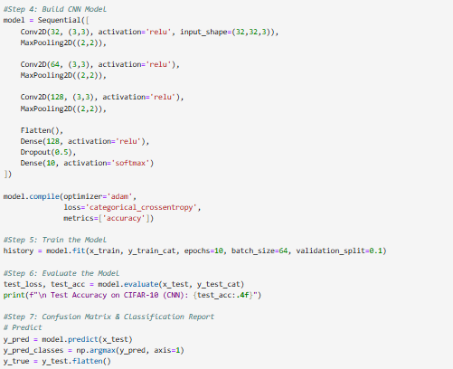

Lab #12

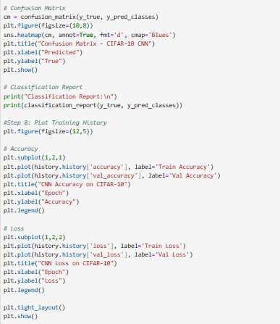



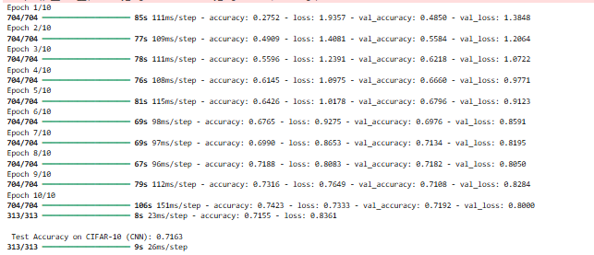

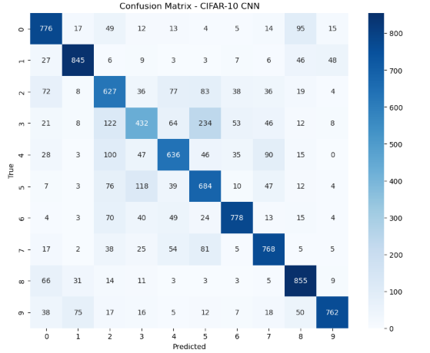

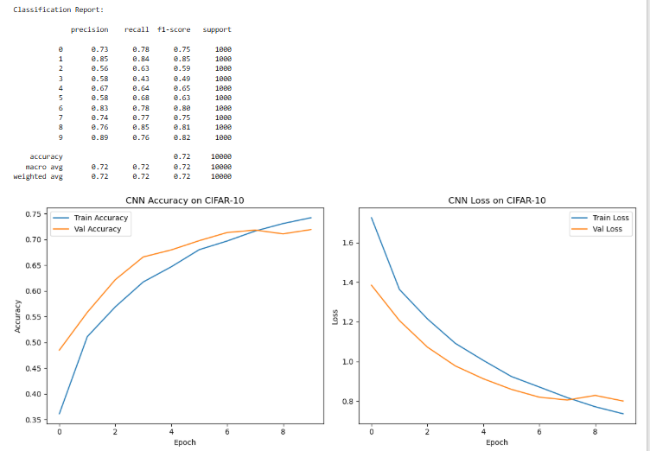

Lab# 12

Activity- 1:
Write a python program to remove stop words from any passage using NLTK.
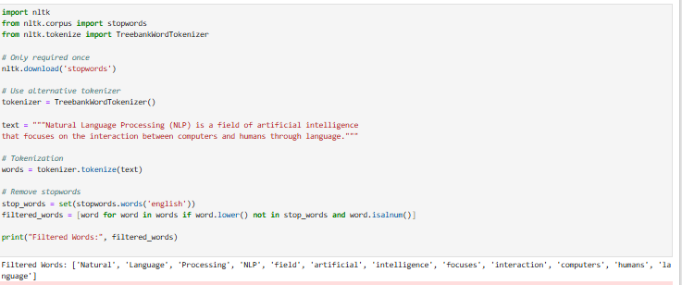

Activity- 2:
Write a python program to POS (Parts of Speech) tagging for any sentence using NLTK.
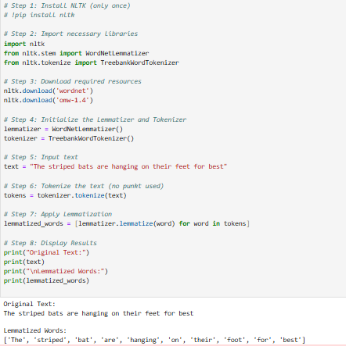

Activity- 3:
Write a python program to implement Lemmatization using NLTK.
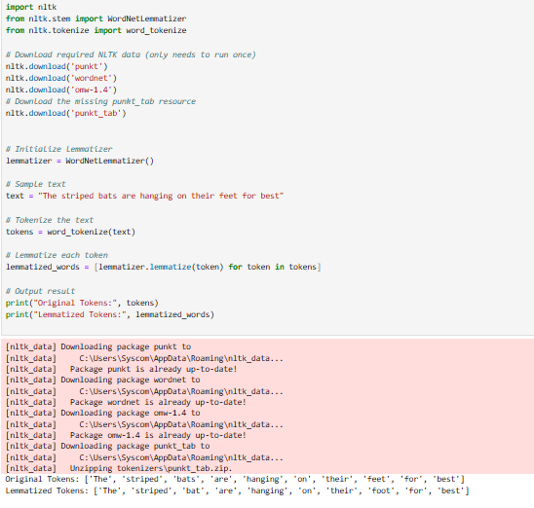

Activity- 4:
Write a python program for Named Entity Recognition for any sentence using NLTK.
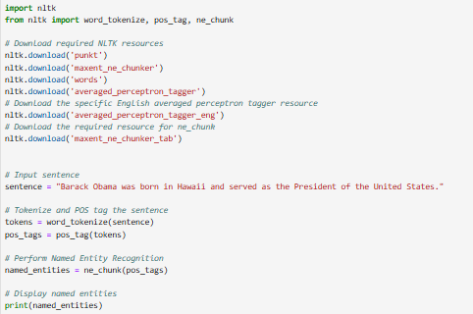

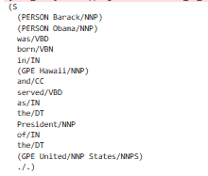

Lab #14

Open Ended Lab could be based on implementation of PYTHON or PROLOG programming.

Implement any scenario of your choice. Complete a task which is different from those taught in class/laboratory or a similar model with enhancements/improvements clearly demonstrated. You can select any specific technique or a model from a research paper. The details should be well documented. Codes should be with comments.

PROLOG
Activity- 12:
Create a basic calculator prolog program for making basic calculations (add, subtract, multiply, divide, average). Use separate goal statements for making each calculation (with constant numeric values).

% Activity 12
% Addition
add :-
write('Enter first number: '), read(A),
write('Enter second number: '), read(B),
Result is A + B,
write('Addition: '), write(Result), nl.

% Subtraction
subtract :-
write('Enter first number: '), read(A),
write('Enter second number: '), read(B),
Result is A - B,
write('Subtraction: '), write(Result), nl.

% Multiplication
multiply :-
write('Enter first number: '), read(A),
write('Enter second number: '), read(B),
Result is A * B,
write('Multiplication: '), write(Result), nl.

% Division
divide :-
write('Enter numerator: '), read(A),
write('Enter denominator: '), read(B),
( B =\= 0
-> Result is A / B,
write('Division: '), write(Result), nl
; write('Error: Division by zero is not allowed.'), nl
).

% Average of three numbers
average :-
write('Enter first number: '), read(A),
write('Enter second number: '), read(B),
write('Enter third number: '), read(C),
Avg is (A + B + C) / 3,
write('Average: '), write(Avg), nl.



Activity- 13:
Make a calculator program by using write() and read() predicates, for taking numeric input from user and displaying text after program execution.




PYTHON
Activity- 4:
If you could invite anyone to dinner. Make a list that includes at least three people you’d like to invite to dinner. Then use your list to print a message to each person, inviting them to dinner.


Activity- 5:
Changing Guest List: You just heard that one of your guests can’t make the dinner, so you need to send out a new set of invitations. You’ll have to think of someone else to invite.
- Modify your list, replacing the name of the guest who can’t make it with the name of the new person you are inviting.
- Print a second set of invitation messages, one for each person who is still in your list.


Activity- 6:
Write a program to read 6 numbers and create a dictionary having keys EVEN and ODD.
Dictionary's value should be stored in list. Your dictionary should be like: {'EVEN':[8,10,64], 'ODD':[1,5,9]}



Activity- 7:
Write a definition of a method count_now(places) to find and display those place names, in which there are more than 5 characters.


